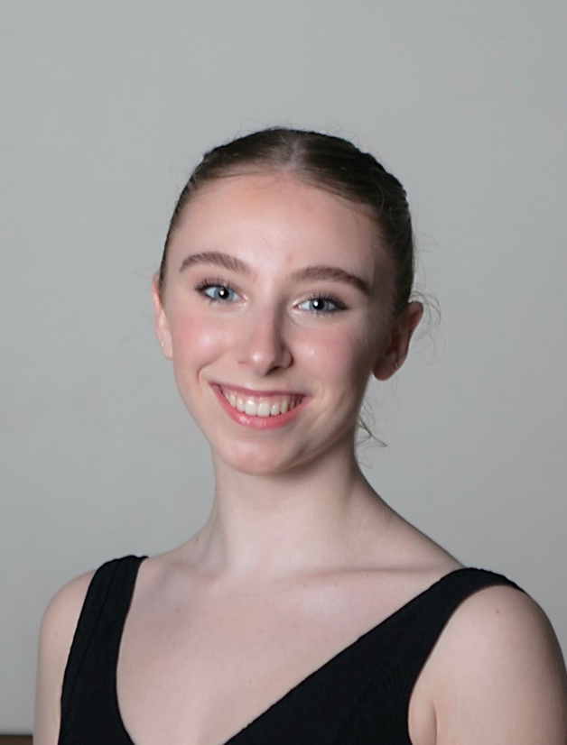
Myah Gadd

D.O.B: 15th of April 2005
Height: 166 cm | 5’6
Weight: 50kg | 110Ibs
Phone No: (+61) 432 592 478
Email: myah_gadd@icloud.com

Professional Employment

2023-2024 The Australian Ballet Story time Ballet
Of Cinderella – short term contract
- Cinderella – choregraphed by David McAllister

2023 short term contract with The Australian Ballet
National Tour - July - August 2023
- Sleeping Beauty Act III - restaged by Paul Knocbloch
and The Australian Ballet
- The Vow - Lucas Jervies
Education
- Victorian College of The Arts Secondary School
- Victorian Certificate of Education (completed 2022)

Performance Experience

2023
Possum Magic (Première) - Loughlan Prior
Glorious Monsters (Première) - Simon Dow
Techno Requiem-in Burgundy (Première) - Lucas Jervies
Raymonda Grand Pas - After Marius Petipa staged by
Key Skills and Strengths
- Nice foot articulation
- High leg extensions
- Strong allegro
- Versatile dance background
- Quick learner
The Australian Ballet School
In Memory of The Moment - Paul Knobloch
The Vow - Lucas Jervies

2022
Pas de Fleur (Le Corsaire) - After Joseph Mazilier,
staged by The Australian Ballet School
Schubert Dances - Stephen Baynes
Awards and Achievements
- American Ballet Theatre Summer Intensive (2019)
- English National Ballet Summer School (2019)
- The Australian Ballet School -Summer School (2019)
- Houston Ballet Summer School (2019)
- Asian Grand Prix (Hong Kong Finalist, 2019)

In Memory of The Moment - Paul Knobloch
Butterfly - Lucas Jervies

2021
Schubert Dances - Stephen Baynes
Butterfly (Première) - Lucas Jervies

2020
Adagio (virtual performance) - Irina Konstantinova
Referees
- Lisa Pavane Email:
lpavane@australianballetschool.com.au
Phone: (03) 9669 2807
- Joanne Michel
- Email:
jmichel@australianballetschool.com.au
- Phone: (03) 9669 2807
Training
The Australian Ballet School Full-Time Programme
2020-2023
- Graduate Diploma of Classical Ballet (Expected Completion December 2023)
- Advanced Diploma of Dance - Elite Performance (2022)
- Diploma of Dance Elite Performance - classical (2021)
- Intensive Spanish Course (Completed 2022)

