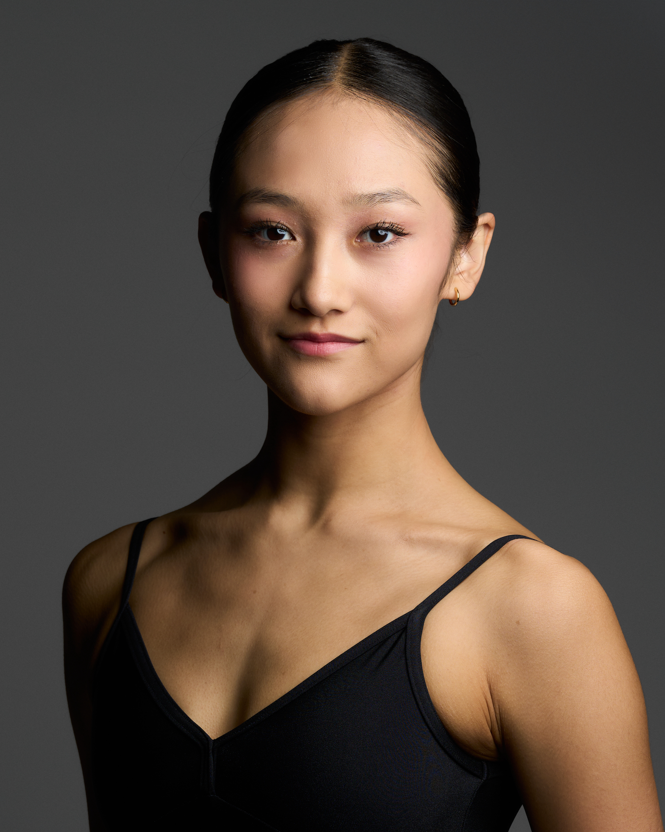
Emma Mills - CV
Video - https://youtu.be/1Pyy0LfBaas
Photos below CV
emmamills2409mt@outlook.com
Phone : +61 468 595 570
Address : 1 Grail Court, Glen Waverley,
Victoria, Australia 3133

DOB : 24/09/2005
Height : 169 cm
Nationality : Australian / Japanese
Languages : English, Japanese

Dance Training
John Cranko Schule, Stuttgart, Germany
September 2022 - Present
Instructors - Tadeusz Matacz, Galina Solovieva, Caterina Mora, Pilar Murube
Dance Styles : Vaganova Classical ballet, Spanish Dance, Kastagnetten, Modern, Pas de Deux

Victorian College of the Arts Secondary School, Melbourne, Australia
January 2018 - September 2022
Instructors - Fiona Munroe, Madeleine Eastoe, Timothy Harbour, Anne Butler, Dr Sela Kiek-Callan, Steven McTaggart, Ross Hannaford
Dance styles : Classical Ballet, Cecchetti Syllabus, Contemporary, Pas de Deux, Composition, Jazz, Tap, Acrobatics

En Pointe School of Ballet
2011 - 2017
Instructors - Renee Grinsted, Hayley Arundal, Elynn Dang, Kurt Dwyer-Williams

Performance Experience
Victorian College of the Arts Secondary School
“Linear Adora”, choreography by Timothy Harbour 2021
“Le Bal”, choreography by Timothy Harbour 2021
“Lure” Dr Sela Kiek, Steven Mctaggart 2022
Lilac Fairy, excerpt of “Sleeping Beauty” 2022

John Cranko Schule
John Cranko 50th Gala 2023
John Cranko Schule ‘Ballet im Park’ 2023

Choreography Experience
VCASS Creative Season ‘Meraki’ 2021 - ‘Kefi’, ‘29/11’
VCE Dance Unit 3 Skill Solo, Composition Solo 2022

Awards and Examinations
Cecchetti Ballet Australia
Levels: Intermediate (Honours), Advanced 1 (Honours), Advanced 2 (Honours)
Enrico Cecchetti Medal Awards, Gold Section 1st Place 2022
