Introducing

lUKAS elliott

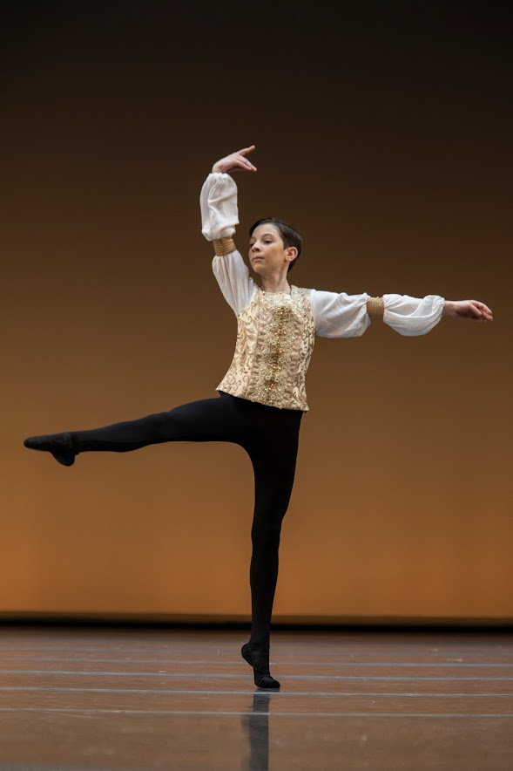
Profile of lukas elliott  bORN 23 July 2010, QLD.  Lukas is a young talented classical ballet student, with a bright personality that permeates on stage! Lukas enjoys stepping out of his comfort zone and facing the physical and emotional challenges of dance auditions, competitions and performances. Along with his successes at such a young age, Lukas is developing strength of character, resilience and to see setbacks as development opportunities by actively seeking feedback.  CURRENT DANCE LEVEL  2023  Level 3 Vaganova Syllabus, Aus Ballet School  Level 5 Conservatoire of Ballet Syllabus,  Glen Iris School of Dance  casting agent  RPR Management  23 Milton Parade, Malvern VIC 3144  info@rprtalentmanagement.com.au  (03) 9832 0818  Contact  PHONE:  +61422112255  INSTAGRAM  Lukas_E_Ballet  FACEBOOK  Facebook.com/EmmaElliott07  EMAIL:  eelliott007@gmail.com  Hobbies  Acting  Dance  Soccer  Athletics  Military History |  | EDUCATION  Wesley College – Melbourne, VIC 3004  January 2023 – current  Academic Year – year 7  South Yarra Primary School – South Yarra. VIC 3141  January 2022 – Dec 2022  Academic Year – Year 6  Saltwater P-9 College – Point Cook. VIC 3030  January 2019 – Dec 2021  Academic Year – Year 3 to 5  Lukas was a member of the college’s Dance Extension group (years 3, 4 and 5).  Lukas also featured dancing in the college’s 2020 promotion video, highlighting the performing arts (dance) program.  dance EDUCATION  Current:  AUSTRALIAN BALLET SCHOOL  January 2020 – Current  Student of Level 3 Intra/Inter/International (ITP) Program.  GLEN IRIS SCHOOL OF DANCE  February 2023 – Current  Lukas is currently a level 5 student Conservatoire of Ballet Syllabus.  Previous:  MELBOURNE/AUSTRALIAN CONSERVATOIRE OF BALLET (MCB/ACB) – Richmond, VIC.  February 2019 – February 2023  Lukas studied from level 2 to level 4 Conservatoire of Ballet Syllabus.  Teachers – Ms. Valmai Roberts. Former dancer of the Australian Ballet Company, Joffrey Ballet, classical ballet lecturer of NYU School of the Arts, American Ballet Theatre, Ballet Hispanico in New York, the Victorian College of the Arts in Australia, and London Contemporary School of Dance and Richard Alston Dance Company in Great Britain.  Mr. John Sandurski. Former Director of MCB. Former member of Introdans (The Netherlands), Staatstheater am Gaertnerplatz (Germany).  Ricardo Ella. Current Managing Director, Operations of ACB. A former actor, stuntman, and Martial Arts instructor, Ricardo's dancing career has been with the Royal New Zealand Ballet (Principal Artist) and The Australian Ballet (Coryphee).  DANCE WORLD STUDIOS (DWS) – South Melbourne. VIC.  February 2019 –March 2020  Lukas studied classical ballet training RAD Grade 3.  Teacher – Naomi Bishop. RAD Board Member. VIC.  Ms. Bishop choregraphed Lukas’ classical repertoire for the Ballet Teachers Workshop. Lukas was a finalist in AA Group 2019.  DANCE performance experience  2023  - Ballet Teachers’ Workshop VIC - Scholarship Finalist Group C, Received an Honorable Mention.  - Born to Perform – COMDANCE, VIC – 12 – 14yr Classical Ballet - Received an Honorable Mention.  - Youth Grand Prix (YAGP) Sydney Semi Final 2020/21 Competitor in Youth Men’s age group (12-14 old). Classical Ballet Solo: Swan Lake Act III Siegfried Variation. Awarded a Summer School Scholarship to The Rock School of Dance Education, Philadelphia, USA 2024.  2022  - Australian Ballet Company Melbourne season production of Anna Karenina – Sergei Karenin - March 2022.  - Australian Ballet Company Melbourne season production of Harlequinade – Harlequin - Jun 2022.  - Australian Conservatoire of Ballet Melbourne season production of The Nutcracker – Fritz - Dec 2022.  2021  - Born to Perform – COMDANCE, 6 Jul 2021, Darebin Arts Centre, Preston. VIC – Placed 2nd Brian Nolan Boys Open Classical Any Age – Open category.  - Australian Ballet Company Melbourne season production of Harlequinade – September 2021.  2020  - RAD Boys Dance 20 Summer School, winner Dance Informa competition 2020. Held in Adelaide 02 – 04 Jan 2020.  - National Theatre Ballet School Summer School junior program and showcase. Held 06 – 11 Jan 2020. Winner of the Junior 2021 Summer School Scholarship.  - International Ballet Workshop Summer School, MAARTS, VIC. 28 – 30 Jan 2020.  - Starstruck Dance Competition, 23 Feb 20, Gladstone Park HS, VIC. – Placed 3rd in U/10 years Classical Ballet section. Placed 3rd in U/10 years Lyrical Ballet section.  - Youth American Grand Prix (YAGP) Asia Pacific Virtual Competition - Semi Final 2020/21 Competitor in Pre-Competitive Men’s age group (9 – 11 yrs old). Classical Ballet Solo: Swan Lake Act III Siegfried Variation.  2019  - Ballet Teachers’ Workshop, VIC – Winner of Group A (8-year-old age group).  - Ballet Teachers’ Workshop, VIC - Scholarship Finalist Group A  - Victorian State Youth Ballet. Successful Audition – Performed in The Nutcracker Production.  - Australian Ballet/Houston Ballet Companies production of Sylvia as a cupid and the farmer’s son (Farmer/Father – Kevin Jackson and Mother -Ako Kondo).  - The Australian Ballet School. Successful Audition – Level 1 ITP student.  2018  - Ballet Teachers’ Workshop, VIC – Honorable Mention AA Group (6/7-year-old age group).  MODELLING experience  2021  - Enpointe Productions 2021 Junior Ambassador Dance Model.  ACTING experience  2022  Nintendo Autumn Commercial Child actor – May 2022.  The Spooky Files – Child Actor/extra – Dec 2022/Jan 2023  SINGING experience  2023  Annelise’s Singing Studio – private singing lessons  Teacher – Annelise Hall  Her recent work includes Sandy in Grease at QPAC, Sophie in Mamma Mia, Soprano in the Quartet for The Lord Mayor's Christmas Carols on Channel 9, the Onstage Swing/Jenny understudy in Aspects of Love at the Hayes Theatre. In 2017, Annelise won the Hollywood Immersive scholarship out of 13,000 people worldwide. Annelise also speaks fluent French.  Jamie Long Singing Studio – private singing lessons  Teacher – Jamie Long  2020/2021  MUSICA FABRI PTY LTD – private singing lessons  Teacher – Mr. Michael Lapiña  Tenor Michael Lapiña began his professional career in 1988 performing in musicals and touring extensively in Australia and Asia. Since 2008, Michael has been engaged with many of Australia’s leading opera houses to perform some of the most coveted tenor roles in the operatic repertoire. His roles have included Nemorino in Donizetti’s L’ELISIR DAMORE, Cavaradossi in Puccini’s TOSCA, Pong and Emperor in TURANDOT, Beppe and Canio in Leoncavallo’s I PAGLIACCI, Remendado in Bizet’s CARMEN, Don Alvaro in Verdi’s LA FORZA DEL DESTINO, Alfredo in LA TRAVIATA, Manrico in IL TROVATORE, and the title role in Gounod’s FAUST.

