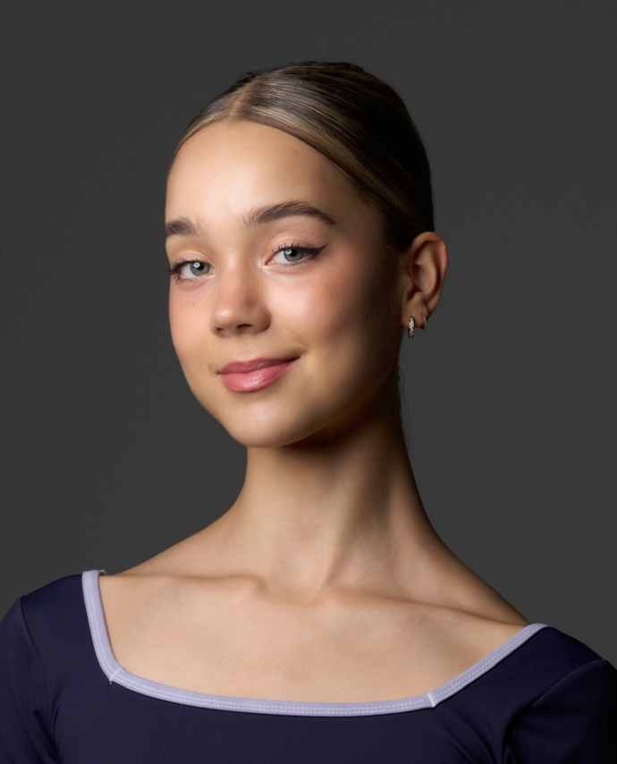
Eva Bakker

Nationality: | Dutch
Adress: | Soetendaal 3, 1081BL  Amsterdam
Date of birth: | 18-07-2006
Height: | 168 cm
Telephone: | +31 6 12630145
E-mail:  Languages: | evahiske@gmail.com  Dutch, English, German

Ballet Education
2015 – Present
Dutch National Ballet Academy
Artistic Director: Ernst Meisner
Ballet teachers: Nathalie Caris, Grigori Tchitcherine, Ainara Garcia Navarro, Emanouela Merdjanova, Simona Ferrazza, Laurence Korsenti, Rinat Gizatulin, Ernst Meisner
Contemporary teachers: Amy Raymond, Lia Witjes Poole

Professional Experience
Dutch National Ballet season 2023/24: Production of Giselle, by Rachel Beaujean and Ricardo Bustamante after Marius Petipa | Corps de Ballet act 1 and 2
Dutch National Ballet season 2022/23 & 2019/20: Production of Swan Lake, by Rudi van Dantzig and Toer van Schayk | Corps de Ballet act 2 and 4, peasants act 1

Artistic Director: Ted Brandsen

Complementary Artistic Education and Training
2023
Royal Danish Ballet Summer School, student exchange scholarship
Prize from Dansersfonds ’79 by Han Ebbelaar and Alexandria Radius
Ballet Masterclasses in Prague with Daria Klimentová

2022
Finnish National Ballet Summer School
Ballet Masterclasses in Prague with Daria Klimentová
Eva Bakker
2/2

Repertoire danced
2023
Paquita choreography by Rachel Beaujean after Marius Petipa, Corps de Ballet
Poulenc Suite choreography by Ernst Meisner, Demi-soloist
Raymonda pas de trois choreography by Rudolf Nureyev after Marius Petipa
Giselle pas de quatre by Rachel Beaujean and Ricardo Bustamante after Marius Petipa
And Then choreography by Ken Ossola

2022
Garland Dance choreography by Ernst Meisner
Choreography by Wubkje Kuindersma
Gottschalk Demo choreography by Grigory Tchitcherine

2021
Jota choreography by Grigori Tchitcherine
Odalisque pas de trois choreography by Marius Petipa

2020
Breathe choreography by Peter Leung

2019
Bolero choreography by Gregor Seyffert
Paquita Mazurka choreography by Rachel Beaujean after Marius Petipa

References
Ernst Meisner | ernst.meisner@ahk.nl
Nathalie Caris | nathalie.caris@ahk.nl
Grigori Tchitcherine | grigori.tchitcherine@ahk.nl

