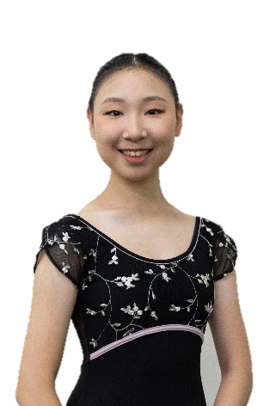
Personal Resume
Name: Ting-Hsin Chang
Country of Citizenship : Taiwan (R.O.C.)
Date of Birth : December 9, 2005
Height: 168cm

■Education:
Keystone Online School

■Ballet Training
2023-2024 The Washington School of Ballet Professional Training Division
2023 School of Philadelphia Ballet Summer Intentive
2022-2023 The Rock School for Dance Education Professional Training Division
2021-2022 Ellison Ballet Year-Round Professional Training Program
2021 Bolshoi Ballet Academy Summer Intensive in New York City
2019 Universal Ballet Summer Ballet School in Seoul

■Competition Experience:
2023 3th Place in 10th World Ballet Art Competition Grand Prix Final in Canada
2023 1st Place in 10th World Ballet Art Competition Grand Prix Semi-Final in Taiwan
2022 1ST Place in ensemble at YAGP Semi-Final NY
2020 10th Place in 7th World Ballet Art Competition Grand Prix Final
2020 2nd Place in classical variation at Star of Canaan Dance International Ballet Competition
2020 3rd Place in comtemporary at Star of Canaan Dance International Ballet Competition
2020 1st Place in World Ballet Art Competition Grand Prix in Taiwan
2020 2nd Place in 8th Taiwan Grand Prix International Ballet Competition
2020 2nd Place in 4th Formosa Solo Competition Junior Classical Ballet
2019 1st Place in GET THE BEAT TAIPEI 2019 SOLO (13&U BALLET) and Regional Teen TOP 5
2019 1st Place in 3th Formosa Solo Competition Junior Classical Ballet
2019 Final round in 1st Taiwan Ballet Competition
2017 1st Place in Chiayi City Student Dance Competition Individual Chinese Dance
2017 2nd Place in Chiayi City Student Dance Competition Individual Chinese Dance
2016 3rd Place in Chiayi City Student Dance Competition Individual Chinese Dance

■Performance Experience
2021 Winter showcase at Ellison Ballet
2022 Spring showcase at Ellison Ballet
2022 Nutcracker with The Rock School for Dance Education

