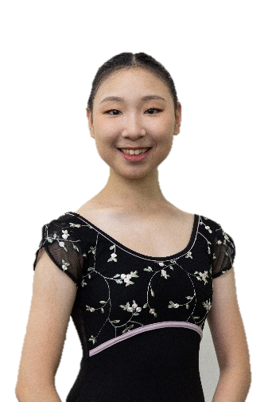
簡歷
姓名：張庭馨
目前就讀嘉義市立嘉義國中舞蹈班一年級

■學歷：
嘉義市博愛國小
嘉義市崇文國小舞蹈班
嘉義市立嘉義國中舞蹈班

■芭蕾訓練
2022-2023 The Rock School for Dance Education
2021-2022 Ellison Ballet Year-Round Professional Training Program
2021 Bolshoi Ballet Academy Summer Intensive in New York City

■比賽經歷：
2019 GET THE BEAT TAIPEI 2019 SOLO (13&U BALLET) 第一名
2019 第三屆福爾摩沙獨舞大賽國中古典芭蕾組第一名
2019 第一屆台灣芭蕾大賽 入圍決賽
2018 台北皇家芭蕾舞團第十屆芭蕾大賽優等
2018全國學生舞蹈比賽國小組個人古典舞優等
2018全國學生舞蹈比賽國小組團體現代舞優等
2017嘉義市學生舞蹈比賽國小組個人古典舞優等第一名
2017嘉義市學生舞蹈比賽國小組個人民俗舞優等第二名
2016嘉義市學生舞蹈比賽國小組個人民俗舞優等第三名

■表演經歷
2019嘉義市興嘉國小管樂團成果發表會舞者
2019嘉義市嘉義國中舞蹈班成果發表會
2018足夢舞人踢踏舞團演出
2016-2018韻鈴舞蹈團年度成果發表會
2015-2018嘉義市崇文國小舞蹈班年度成果發表會
2013-2018童蓁舞蹈班年度成果發表會

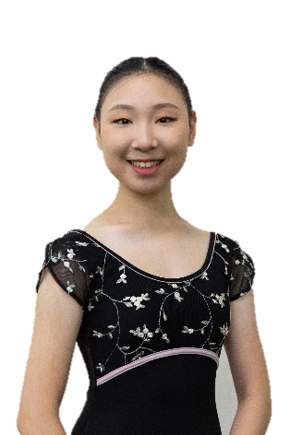
Personal Resume
Name: TING-HSIN CHANG
Country of Citizenship : Taiwan
Date of Birth : Dec. 9, 2005
Height: 169cm

■Education:
Chiayi Bo-ai Elementary School
Chiayi Chung-Wen Elementary School Dance Class
Chiayi Municipal Chiayi Junior High School Dance Class.
Keystone Online School

■Ballet Training
2023-2024 The Washington School of Ballet Professional Training Division
2023 School of Philadelphia Ballet Summer Intentive
2022-2023 Year Program of The Rock School for Dance Education
2021-2022 Ellison Ballet Year-Round Professional Training Program
2021 Bolshoi Ballet Academy Summer Intensive in New York City
2019 Universal Ballet Summer Ballet School in Seoul

■Competition Experience:
2023 3th Place in 10th World Ballet Art Competition Grand Prix Final in Canada
2023 1st Place in 10th World Ballet Art Competition Grand Prix Semi-Final in Taiwan
2020 10th Place in 7th World Ballet Art Competition Grand Prix Final
2020 Second Place in classical variation at Star of Canaan Dance International Ballet Competition
2020 Third Place in comtemporary at Star of Canaan Dance International Ballet Competition
2020 First Place in World Ballet Art Competition Grand Prix in Taiwan
2020 Second Place in 8th Taiwan Grand Prix International Ballet Competition
2020 Second Place in 4th Formosa Solo Competition Junior Classical Ballet
2019 First Place in GET THE BEAT TAIPEI 2019 SOLO (13&U BALLET) and Regional Teen TOP 5
2019 First Place in 3th Formosa Solo Competition Junior Classical Ballet
2019 Enters Finalist in 1st Taiwan Ballet Competition
2018 Excellence in 10th Taipei International Ballet Grand Prix Primary School
2018 Excellence in National Student Dance Competition Primary School Individual Classical Dance
2018 Excellence in National Student Dance Competition Primary School Group Modern Dance
2017 First Place in Chiayi City Student Dance Competition Primary School Individual Classical Dance
2017 Second Place in Chiayi City Student Dance Competition Primary School Individual Performance Show
2016 Third Place in Chiayi City Student Dance Competition Primary School Individual Performance Show

■Performance Experience
2021 Winter showcase at Ellison Ballet
2022 Spring showcase at Ellison Ballet
2022 Nutcracker with The Rock School for Dance Education

