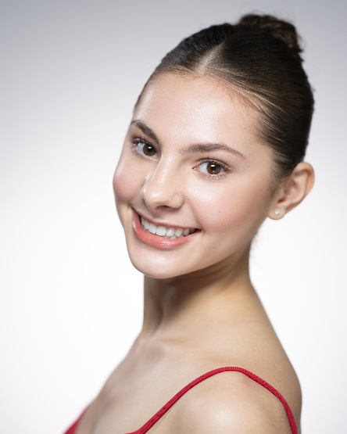
Madeline Halkos

Manresa Rd, Flat #717, Lightfoot Hall Homes for Students
Chelsea, London SW3 6NA United Kingdom
+44 (0) 7949243448 or
+1 (404)-539-3113
madeline.halkos@enbsstudent.org.uk
https://www.instagram.com/madeline_halkos/

PERSONAL INFORMATION

Nationality: American Languages Spoken: English
Date of Birth: March 28, 2005, age 18 Height: 165cm / 5ft 5 in
Citizenship: United States of America

EDUCATION & TRAINING

September 2021 – present: English National Ballet School
Artistic Director: Viviana Durante
Faculty: David Beer, Michael Berkin, Juan Eymar, Monique Jonas, Senri Kou, Sebnem Onal, Nicola Simpson, David Yow

September 2018-May 2021: Terminus Ballet School
Artistic Director: Christine Welker
Faculty: Christian Clark, Heath Gill, Alex Gonzaga, Tara Lee, Laura Morton La Russa, Rachel Van Buskirk, John Welker

September 2012 – May 2017: Atlanta Ballet
Artistic Director: John McFall
Faculty: Kate Gaul, Armando Luna, Nadia Mara, Sharon Story

PERFORMANCE EXPERIENCE

07/2023: ENBS Summer Showcase: center Sylph in the trio of Sylphs in La Sylphide, August Bournonville, and coached by Peter Schaufuss. Flock, a contemporary piece by Monique Jonas

05/2023, 10/2022 and 06/2022: Young Choreographer’s Performance, the Wallace Collection Museum, London, England

12/2022: ENBS Winter Showcase: Swan Lake Act 1 Waltz, La Fille Mal Gardee Female Variation

07/2022: ENBS Summer Showcase: Ponte Molle, August Bournonville and coached by Dinna Bjorn, Lead Female role; Etude; a character piece by Amanda Maxwell

06/2016: Atlanta Ballet’s Princess and the Goblin, Twyla Tharp, coached by Sarah Hilmer

12/2015, 12/2016: Atlanta Ballet’s Nutcracker, John McFall, various lead children’s roles

COMPETITION, AWARDS, SUMMER INTENSIVE ATTENDANCES, & ACKNOWLEDGMENTS

06/2021: Houston Ballet Summer Intensive, Houston, TX
06/2019: Full Tuition Scholarship to Houston Ballet’s Summer Intensive in Houston, TX, USA, and offer of place for the year-round school program
03/2019: Universal Ballet Competition 3rd place winner, Aurora Act III, Atlanta, GA
08/2017: Royal Ballet Summer School, London, UK
06/2017: San Francisco Ballet Summer Intensive, San Francisco, CA
06/2015 and 06/2016: Atlanta Ballet Summer Intensive, Atlanta, GA
07/2014: Bolshoi Ballet Summer Intensive, NYC, NY

