Calen Fulton Sutherland

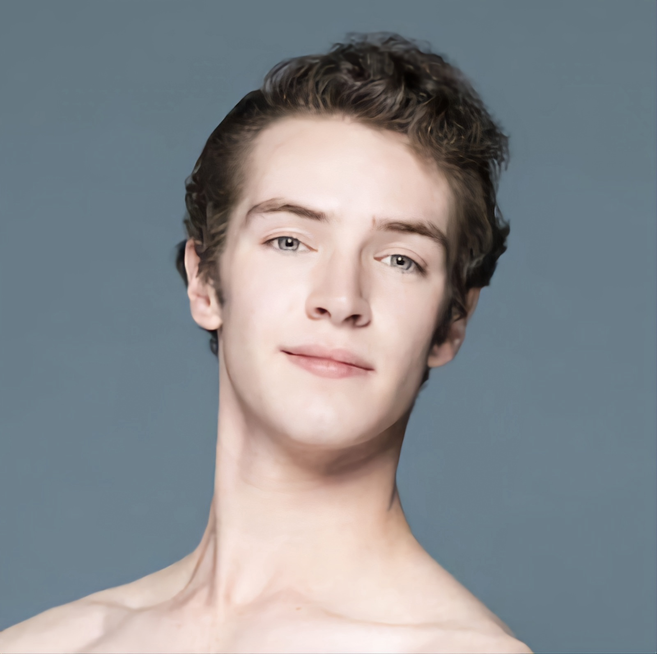

2481 Merrion Park Ct
Dacula, GA 30019
470-408-0221
calenfulton@gmail.com
@calen_sutherland
Height: 5’ 11”
D.O.B. 7/16/2001

Company Work
2022-2023: Sarasota Ballet- Apprentice – Iain Webb- Artistic Director
2021-2022: Sarasota Ballet- Studio Company – Iain Webb- Artistic Director
Training
2019-2020: Orlando Molina Ballet Training Center – Orlando Molina
2018-2019: Metayer Conservatory for the Arts – Regine Metayer
2012-2018: Gwinnett Ballet Theatre – Wade Walthall
Summer Programs
2019: Houston Ballet – Melissa Bowman
2018: The Rock School – Bo and Stephanie Spassoff
2017: Pacific Northwest Ballet – Peter Boal
2016: School of American Ballet – Kay Mazzo
2015: The Rock School – Bo and Stephanie Spassoff
2014: Next Generation Ballet – Peter Stark
Scholarships Accepted and Received
2020: Pacific Northwest Ballet – Full – Summer Program
2019 – Houston Ballet – Full - Summer Program
2018 – The Rock School – Full – Summer Program
2017 – Pacific Northwest Ballet – Full Tuition – Summer Program
2016 – School of American Ballet – Full Tuition – Summer Program
2015 – The Rock School – Full – Summer Program
2014 – Next Generation Ballet – Full – Summer Program
2018/19 – Metayer Conservatory for the Arts – Year-round
2012-2018 – Gwinnett Ballet Theatre – Year-round
Awards and Recognitions
2020- Universal Ballet Competition – Atlanta
* 5th place Senior Classical, 1st Place Senior Pas de Deux, 1st Place Contemporary Duet
2020 – Youth America Grand Prix – Atlanta Regional
* 3rd Place Senior Classical
* Top 6 Ensemble – Sugarplum – Pas de Deux
2019 – AFA Choreography Worshop at Houston Ballet
Performance Experiences
2023- Metropolitan Ballet Theater – Maniya Barredo – “Coppelia” – Franz; “The Nutcracker” – Cavalier/Snow King
2021-2023 - Sarasota Ballet- Iain Webb – Voices of her” – Palladio; “Rakes Progress” – Musician/Bishop; “Façade” – Yodeling Boy; “Frequency Hurtz” – Men; “Elite Syncopations” – Corps; “A Comedy of Errors” – Corps; “Dante Sonata” – Child of light; “Nutcracker Excerpts” – Cavalier/Snow King; “Coppelia Excerpts” – Franz; “Magnificat” – Men; “Images of Dance” – Principal Male
2021 - Mt Dora School of Ballet – Kathryn Wheeler- “The Nutcracker” – Cavalier\Kissy Doll
2021-2022 – Diane Partington School of Classical Ballet – Diane Partington – “The Nutcracker” – Cavalier; “Sleeping Beauty” – Prince
2020 – Georgia Metro Dance Theater – “Coppelia” –
2019 – St. Augustine Ballet – Luis Abella - “The Nutcracker” – Cavalier
2019 – Intempo Dance – Rocio Braggiato - “The Nutcracker” – Cavalier
2019/18- Perimeter Ballet – Becky Brown – “Cinderella” – Ballroom Court; “Beauty and the Beast” – Gaston
2016/18/24 – Still Pointe Ballet – Eleanor Rogers – “Gerda and the Snow Queen” – Prince/Kai; “Coppelia” – Franz
2018/19 – Sawnee Ballet Theatre – Courtney Bromwich - “The Nutcracker” – Cavalier, “Beauty and the Beast”–Beast
2018 – Atlanta Professional Dance Academy – Wei Dongsheng - “Le Corsaire” pas de deux
2018 – City Gate Dance/Metayer CFA – Regine Metayer - “A Christmas Fairytale” – Cavalier, Chinese lead, Mirliton pas de trois
2017-2012 – Gwinnett Ballet Theatre – Wade Walthall
- “Nutcracker” – Fritz, Russian Corps, Russian Lead, Mouse King, Cavalier
- “Journey” - an original ballet by Wade Walthall – Father, Perseus (lead)
- “Cinderella” – Ballroom corps, Dance Master
- “Disney…Songs and Pictures” – Lead and duet/ensemble
- “19, 20, 21 by Wade Walthall” – “Pictures” lead, demi-soloist

