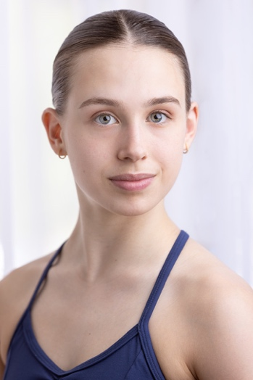
Juliette Bienvenu
80 rue rose Pierrefonds
Montréal (Québec)
H8Y 2B9
Phone number: +1 (514)709-5807
jubienvenu11@icloud.com
Height: 167 cm
20 years old
Canadian

Dance education:

- 2020 to today; training in a pre-professional program at Ballet Montreal Performing Art School (ballet, contemporary, modern, and jazz)
- 2019 to today; member of the Ballet Montreal Junior Company
- 2016 to 2020; training at École de danse Eddy Toussaint and apprentice in their professional company
- 2013 to 2016; training at École de danse Rose-Marie Mullen
- 2007 to 2016; training at L’académie de Danse Classique de Lachine
Dance experience:

- Dutch National Ballet summer intensive 2022
- Dance the role of Gamzatti and the first shade in La Bayadère production of Ballet Montreal (June 2023)
- Dance the role of Friends, Cupid and a bridesmaid in the Don Quichotte production of Ballet Montreal (June 2022)
- Dancer with the company Eddy Toussaint (Nutcracker, La vie d’Édith Piaf, fundraising event)
- Part-time job as a dance teacher (pre-ballet and level 1)
- Dancer in the Ballet Ouest Nutcracker
- Contestant in the television dance competition Revolution

Competition:

- 2023 Youth American Grand Prix Boston top 24 in classical/contemporary and first place as a duet with an invitation to the final
- 2022 Youth American Grand Prix final
- 2022 Youth American Grand Prix top 24 classical variation at the Toronto semi-finale
- 2021 Youth American Grand Prix competition (Second place in the ensemble category in the Canadian semi-final)

Certification:

- Cecchetti Society of Canada intermediate and advance 1 exam
- Society of Russian Ballet Vaganova exam level 7, pre-elementary and intermediate
- Society of Russian Ballet exam for student teacher-in-training

Extracurricular art:

- Musical formation in high school and member of the school orchestra
- Musical summer intensive of Collège Beaubois (2015 to 2020)
- Piano lesson

Education:

- High school diploma at Collège Beaubois with high distinction (2015 to 2020)
- Cegep diploma in natural science (2020 to 2023)

