Anna Kate Jones |  | performance experience  2019-2022 & 2023-2024- The Georgia Ballet:  - A Midsummer Night’s Dream- Hermia, Butterfly  - The Nutcracker- Clara, Soldier Doll Pas de Deux, Mirlintons, Flowers Soloist, Snow, Arabian, Party Mother, Young Party Woman, Sugarplum Attendant  - Giselle: Willis Corps de Ballet,  Village Ladies(understudy)  - Coppelia- Spanish Doll, Village Maiden, Coppelia Doll  - Cinderella- Winter Fairy, Suitor Lady Soloist, Fairies Corps, Waltz Corps  - The Legend of Sleepy Hollow- Schoolgirl  - Coppelia Excerpt- Waltz of the Hours  - Sleeping Beauty Excerpts, Finger Fairy, Corps de Ballet  2022-2023- The Sarasota Ballet & The Sarasota Ballet School  The Sarasota Ballet  - Dante Sonata- Child of Darkness  - Western Symphony- 2nd Movement,  1st Movement (Understudy)  - Four Temperments- Sanguinic (Understudy)  - La Sylphide- Sylph pas de trois (Understudy)  The Sarasota Ballet School  - Coppelia- Swanhilda’s Friends, Waltz of the Hours  - Luminosity- Corps de Ballet  - The Nutcracker- Marie, Shepherdess Soloist, Snow, Flowers  - Paquita- Friends/Corps de Ballet  - Ballad of the Brown King (Understudy)  - Danse Macabre Pas de Quatre (Understudy)
  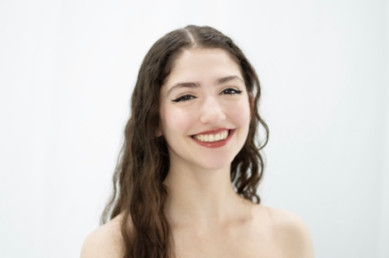
  Email:
  a.k.enpointe@gmail.com
  PHone Number:
  470-519-5073
  Address:
  4544 Mars Court,
  Acworth, Ga 30101
  Height:
  5’5”
  Instagram:
  @anna.k.ballet
  Date of Birth:
  October 12, 2004
  19 years OLD
  Accolades & Acknowledgements
  - YAGP Top 24 Senior Classical- Atlanta Regional, February 2022
  - YAGP 3rd place Ensemble, Vivaldi
  - UBC Platinum and 3rd place Ensemble, Vivaldi
  - Scholarships to:
      - Sarasota Ballet Trainee Program
      - The Georgia Ballet School Conservatory
      - Sarasota Ballet Summer Intensive
      - Bolshoi Ballet Summer Intensive
  Company work
  2022-2023: The Sarasota Ballet- Trainee- Artistic Director: Iain Webb
  2023-2024: The Georgia Ballet- Corps de Ballet- Artistic Director: Daet Rodriguez
  Training
  2019-2022: The Georgia Ballet- Conservatory and Student Trainee School Director: Ashleyanne Hensley
  Other Faculty: Ashleyanne Hensley, Daet Rodriguez, Margit Rodriguez, Lauri Worril-Biggs, Courtney Locke, Leslie Parker
  2022-2023: The Sarasota Ballet School- Trainee
  School Director: Christopher Hird
  Other Faculty: Dierdre Miles-Burger, Lindsay Fischer, Risa Kaplowitz, Addul Manzano
  Summer Intensives
  2019: Atlanta Ballet’s Summer Intensive
  2021: Bolshoi Ballet Academy’s Summer Intensive
  2022: Sarasota Ballet School’s Summer Intensive

