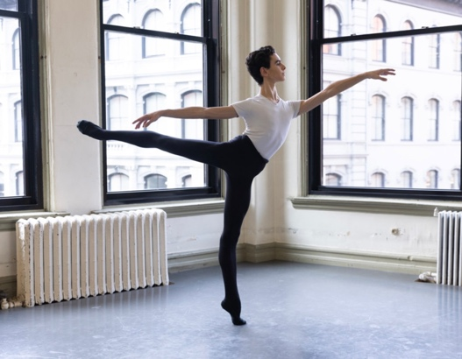
Jorge Lamelas

Jl@jorgelamelas.com
+34 649 77 65 38
Age: 17 yrs
08/31/2006
Citizenship: Spain

Pre-Professional Training

ABT JKO School Pre-Professional Division Upper 3 2022-2024

Artistic Director, Stella Abrera
Principle Teachers, Rubén Martín, Yan Chen
Guest teachers, Sascha Radetsky, Carlos Lopez, Franco De Vita

Conservatorio Carmen Roche (Madrid). 2019 – 2021
Artistic Director, Carmen Roche. Teachers, Lorena Jimenez

Awards / Scholarships

ABT JKO School full year and Summer Intensive scholarship 2023
ABT JKO school full scholarship from Cynthia Harvey 2022
Youth American Grand Prix final round 2022
Royal Ballet School short-term scholarship and school entry 2021
Dutch National Ballet School summer Intensive scholarship 2021
First place winner, Prodigios Spain competition from Nacho Duato 2021

Performance / Repertoire

ABT Fall Gala “Piece D’occasion.” 2023
Choreographers, Lauren Lovett and Rubén Martín, David H. Koch Theater, Lincoln Center NYC.

Complexions Gala Night collaboration with ABT JKO School Upper 3 2022
Choreographers Desmond Richardson, Natiya Kezevadze, Joyce Theater, NYC.

“Romantic Waltz” contemporary performance to Chopin Waltz no. 19. 2022
Ángel Rodríguez, Stratz Center for the Performing Arts

Dance training experience and curriculum

Classical ballet
Pas de deux
Variations and classical repertoire
Contemporary
Graham technique
NIQUE Complexions technique
Nacho Duato repertoire
Jazz technique
Musical theater and tap

