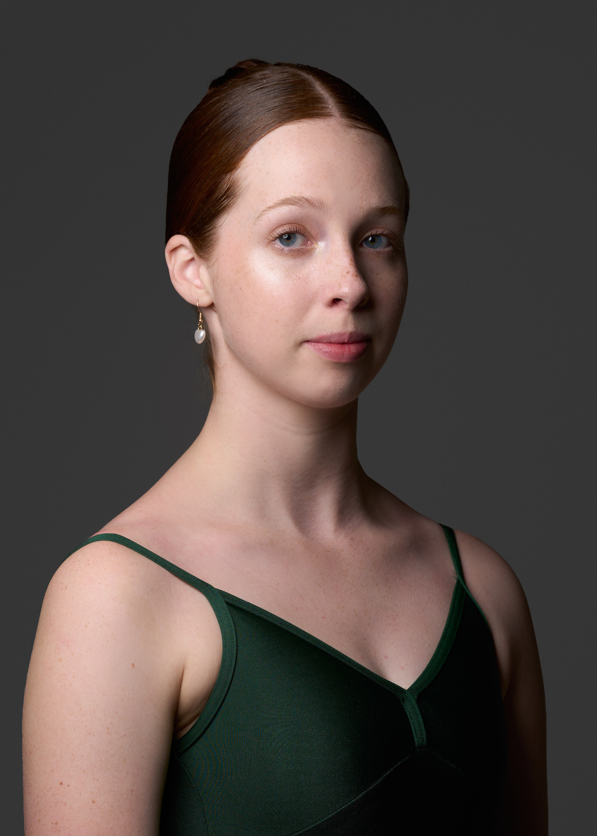
Experience
Association of Russian Ballet & Theatre Arts Gala, 2023
Bristol Russian Ballet School Gala, 2023
Kings International Ballet Academy Summer Performance (Sleeping Beauty Corps de Ballet & Fairy of the Woodland Glade), 2023

Training
Kings International Ballet Academy, 2022-2024
Edinburgh Festival Ballet School, 2020-2022

Summer Intensives & Additional Training
John Cranko Schule Summer Intensive, 2022 & 2023
Longiano in Danza Summer Intensive, 2023
Dutch National Ballet Academy Summer Intensive, 2022
American Ballet Theatre Summer Intensive, 2021
Private Coaching with Paola Vismara, 2023
Private Coaching with Yosvani Ramos, 2023

Qualifications
SQA Higher National Diploma in Dance Performance, 2020-2022
Association of Russian Ballet & Theatre Arts Intermediate Exam (with Distinction), 2023

Profile
Experience working with directors, choreographers & dancers including:
- Stephen Delattre (Director of Delattre Dance Company)
- Dario Biuso (La Compagnia Koreos Ballet)
- Luca Braccia (Artist at Barber Dance, Lecturer at Studio Wayne McGregor)
- Yosvani Ramos (Former Principal w/ English National Ballet, Australian Ballet, Colorado Ballet & Cincinnati Ballet)
- Luke Schaufuss (Principal Dancer at Sarasota Ballet)
- Daniel Cardoso (Director & Founder of Quorum Ballet)

CONTACT

EMAIL
lauraforrester04@icloud.com

PHONE
+44 7576382049

PERSONAL INFORMATION

CITIZENSHIP
Irish (EU)
Australian
British

DOB 05/06/2004

HEIGHT 173cm

WEIGHT 61kg

HH
Laura Forrester

