Charlotte Cohen
  - Royal Ballet School
- Education  Royal Ballet Upper School (English): 2021 - Current  Currently in Graduate Year  (Christopher Powney, Jessica Clarke, Nicola Tranah, Daria Klimentova)  Australian Conservatoire of Ballet (Vaganova Based): 2015 – 2021  Completed Certificate IV and Advanced Diploma in Dance  Completed Ballet Conservatoire Syllabus- Level 2-Excellence (Received Distinctions)  (Christine Walsh AM, Ricardo Ella, Valmai Roberts)  Gay Wightman School of Dance: 2009 – 2014  Beginners – Grade 3  WORK EXPERIENCE  Royal Ballet School: 2021- 2023  Birmingham Royal Ballet Nutcracker – Snowflake and Waltz of the Flower (Sir Peter Wright)  Grand Defile 2023 – Soloist in Don Quixote Act 2 (Carlos Acosta), Bold (Goyo Montero), Four Seasons (Sir Kenneth MacMillan)  Grand Defile 2022 – Swan Lake Pas de Douze (Sir Frederick Ashton), Raymonda Czardas (Rudolf Nureyev)  Unite for Ukraine Schools Gala 2022 – Swan Lake Pas de Douze  Australian Conservatoire of Ballet: 2015 - 2022  Nutcracker 2022 (Christine Walsh) – Snow Queen, Lead Flower  Sleeping Beauty 2019 (Christine Walsh) – Lilac Fairy Attendant, Aurora’s Friend, the White Cat  Nutcracker 2018 (Christine Walsh) – Mouse, Mirliton Corps de Ballet  Swan Lake 2017 (Christine Walsh) – Child  Nutcracker 2016 (Christine Walsh) – Child, Skater, Sugar Plum Fairy Attendant  Coppelia 2015 (Maina Gielgud) – Child |  | 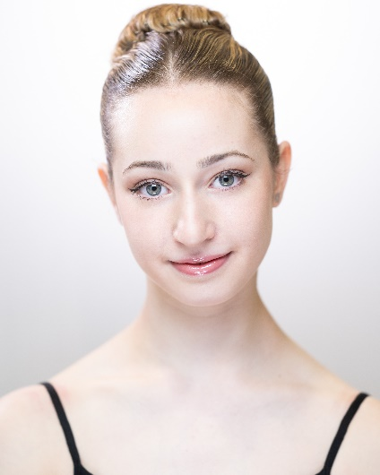  - Profile  Height: 167.8 cm  Nationality: British / Australian  D.O.B: 17/05/2005  Age: 18  - CONTACT  Phone:  +44 7932028033  Address:  46 Floral Street, Covent Garden, London WC2E 9DA  Email:  charlotte.cohen@student.royalballetschool.org.uk
  - Achievements

Platinum Jubilee Celebration 2022

Prix de Lausanne 2021 – Finalist

Ballet Teachers Workshop: 2019 Section D Finalist

ACADEMIC EDUCATION

Royal Ballet School: 2021 – Present
Bachelor of the Arts – Roehampton University

Virtual School Victoria: 2019 – 2021
Year 8 – 10

Camberwell Girls’ Grammar: 2018
Year 7

Ruyton Girls’ School: 2011 – 2017
Prep – Year 6

References

Christopher Powney, Artistic Director / CEO of the Royal Ballet School
christopher.powney@royalballetschool.org.uk
46 Floral Street, Covent Garden, WC2E 9DA

Jessica Clarke, Artistic Manager / Graduate Year Ballet Teacher
jessica.clarke@royalballetschool.org.uk
46 Floral Street, Covent Garden, WC2E 9DA

Nicola Tranah, Second Year Ladies Teacher
nicola.tranah@royalballetschool.org.uk
46 Floral Street, Covent Garden, WC2E 9DA

