December 2023

To whom it may concern

Reference: Melissa Lott

Melissa Lott is currently enrolled as a Third Year student at English National Ballet School. She joined the School in September 2021 and is due to graduate in July 2023.

Melissa is a hardworking and dedicated student with a professional and positive attitude. During her time with the School she has developed her classical ballet and contemporary dance techniques as well as her performance skills as she prepares for upcoming performances. She has shown herself to be a willing collaborator in the studio when working with choreographers.

As part of the course, Melissa has been training in classical ballet and contemporary, as well as receiving coaching in repertoire from a variety of highly experienced dancers and coaches. Students also have performance opportunities working with international choreographers to have new works created for them.

I have no hesitation in recommending her to you. I hope you will consider her for your company.

Yours faithfully

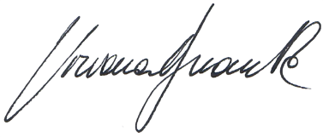

Viviana Durante
Artistic Director

