Pierre Antoine Gobert
Student at the Conservatoire National
Supérieur De Musique Et De Danse De Paris

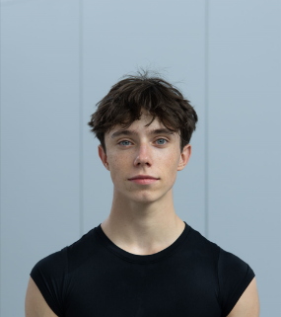
17 years old, Born on the 26 of October 2006
Height : 178 cm, 5’8 feet
Weight : 63 kg, 138 lbs
Citizenship : French
19 bis Rue Des Meuniers, Suresnes, 92150
gobertpa@icloud.com / +33671035639

Scolarity :
2023-2024 : Final year student with M.Gil Isoart as main ballet teacher and M. Laurent Novis as secondary ballet teacher at The Conservatoire National Supérieur De Musique Et De Danse De Paris
Per week I dance : 14 hours of Ballet Classes, including 2 classes of Pas De Deux, 4 hours a week - 8 hours of Contemporary Classes, including improvisation, Cunningham techniques and Néoclassical Classes. Total of 22 hours of dance per week
There is also theoretical classes like music, dance history and anatomy

Main Teacher : M. Gil Isoart
Ballet Teachers : M. Gil Isoart and M. Laurent Novis
Pas de Deux : M. Gil Isoart and Mrs Isabelle Ciaravola
Contemporary & Néoclassical : Mrs Raphaëlle Delauney,
Mrs Cheryl Therrien
Mrs Sylvie Berthome

2022-2023 : DNSP2 student with M. Laurent Novis as main ballet teacher and M. Gil Isoart and M. Serguei Soloviev as secondary ballet teachers at the Conservatoire National Supérieur De Musique Et De Danse De Paris. It included ballet classes, partnering classes and secondary classes : contemporary classes, improvisation class, jazz class, yoga class.

2021-2022 : DNSP1 student with M. Bertrand Belem as main ballet teacher and M. Serguei Soloviev as secondary ballet teacher at the Conservatoire National Supérieur De Musique Et De Danse De Paris. It included ballet classes, pas de deux classes and secondary classes : contemporary classes : Graham techniques, improvisation class
When I enter at the Conservatoire National Supérieur De Musique Et De Danse De Paris, I skipped a year to go to the above one, the DNSP1

2020-2021 : Student at the Ecole du Ballet de Stanlowa with M. Alexis Renaud and Mrs Juliane Mathis from Paris Opera Ballet as main ballet teachers. It included ballet classes and secondary classes : character dance, contemporary, yoga

2018-2020 : Student at the Ecole De Danse De L’Opéra De Paris with M. Bertrand Barena as main ballet teacher. Other classes were teaching like : mime, baroque and folk dance, musical

Stage Experiences :
Le Corsaire, Slave Variation at the open classes of the Conservatoire National Supérieur De Musique Et De Danse De Paris in 2023

La Sylphide, James variation, ACT III at the Prix de Lausanne European Preselection

« I Told You » by Yonggeol Kim in 2023

Swan Lake Hungarian Dance « Czardas » in 2022

Trisha Brown X100 in November 2021 at the Villette Theater Paris

Lucinda Childs X100 in November 2023 at the Villette Theater Paris

Open classes of the Conservatoire National Supérieur De Musique Et De Danse De Paris in 2022

Open classes of the Opera de Paris at the Opera Garnier

Internship :
Summer intensive of The Prix De Lausanne European Présélection : 2023

Summer intensive of The Royal Ballet School : 2023 (3 Weeks)

Summer intensive of The Académie Princesse Grace : 2021, 2022

Summer intensive of Andrey Klemm : 2021, 2023

Winter intensive of Andrey Klemm : 2021, 2022

Publié Summer intensive : 2018, 2019, 2021

Language :
French

English

High School and Diploma :

2023-2024 : Senior year preparing for the French Bacaloréat
2021 : Graduate of the « Brevet des Collèges » with a Honors Mention

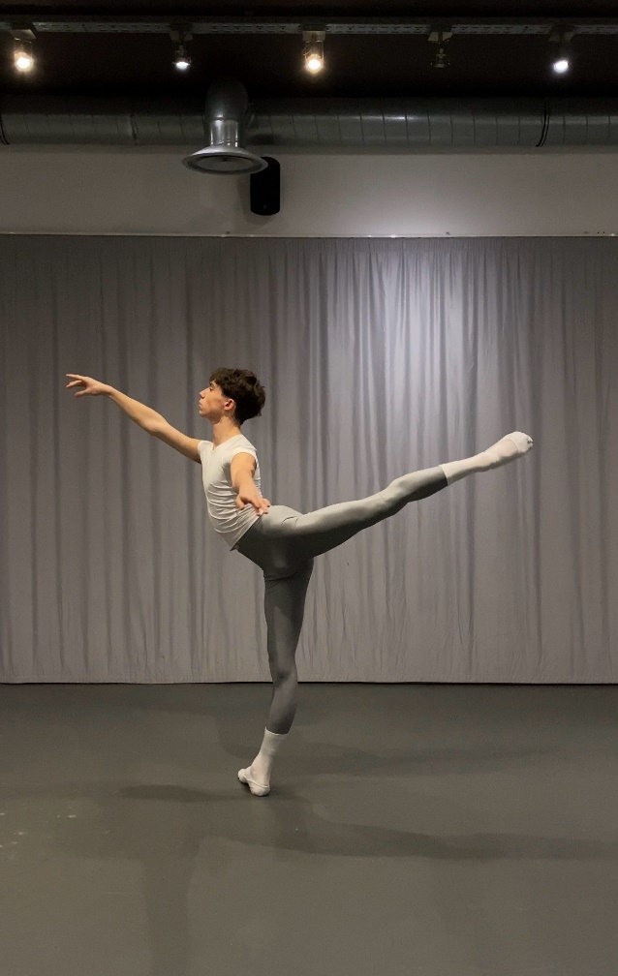
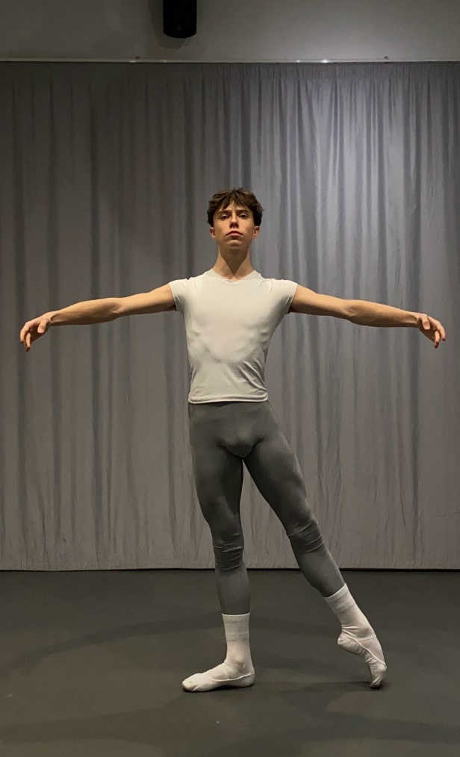
Tendu à la seconde 1st Arabesque

