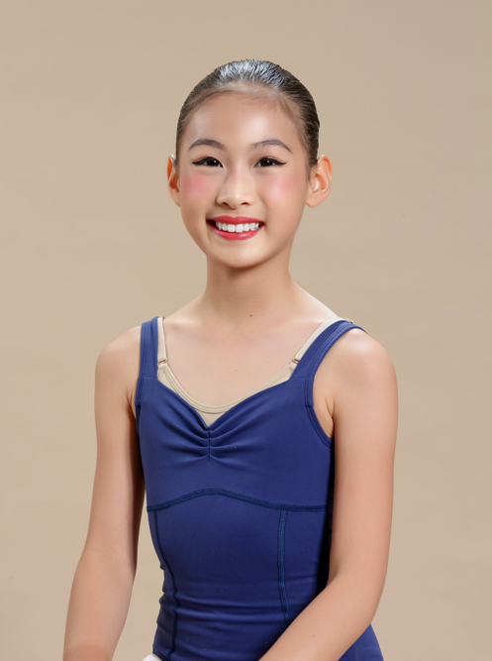
Sophia Maddison Go Lim

PERSONAL DETAILS:
Nickname: Sophie
Born: October 1, 2013
Languages: English, Mandarin, Filipino

Education:
Beacon International School Manila
Kinder (2016) to Grade 5 (Present)

Beats & Steps Arts Academy, St. Ignatius, Quezon City, Classical Ballet, Contemporary Ballet, Jazz (Student (2014 – Present)

Contact Information:
Mobile: +639089820299
e-mail: safetyfirst_911@yahoo.com

PERFORMANCES:

Year | Role | Production | Company/School
2024 | Recitalist | Summer Dance Showcase | Beats & Steps Arts Academy
2024 | Recitalist | “We’re Dancing”, Dance Showcase | Beats & Steps Arts Academy
2024 | Artist | ABAP Cebu Dance Caravan, A Tribute to Nicolas Pacaña | Beats & Steps Arts Academy
2023 | Guest Artist | “Nine Pointe Nine”, RDC Dance Recital | Rhythm and Dance Center (RDC)
2023 | Artist | “Pearled: A Penchant for Classics”, ABAP Danseries Festival | Beats & Steps Arts Academy
2023 | Recitalist | “Arise”, Musical Showcase | Beats & Steps Arts Academy
2023 | Recitalist | “Dance is Life”, Dance Showcase | Beats & Steps Arts Academy
2022 | Guest Artist | “Taking Center Stage”, RDC Dance Recital | Rhythm and Dance Center (RDC)
2022 | Artist | “A Chance to Dance”, ABAP Danseries Festival | Association of Ballet Academies Philippines (ABAP)
2022 | Recitalist | “Thank You for the Music”, Musical Showcase | Beats & Steps Arts Academy
2022 | Recitalist | “Lights, Camera, Dance”, Dance Showcase | Beats & Steps Arts Academy
2022 | Recitalist | “Royals”, RDC Online Dance Recital | Rhythm and Dance Center (RDC)
2021 | Recitalist | “Tunog Natin”, RDC Online Dance Recital | Rhythm and Dance Center (RDC)
2021 | Recitalist | “Harmony”, Musical Showcase | Beats & Steps Arts Academy
2020 | Recitalist | Holiday Dance Showcase | Beats & Steps Arts Academy
2019 | Artist | “Screen to Stage”, ABAP Danseries Festival | Association of Ballet Academies Philippines (ABAP)
2019 | Guest Artist – Mother Ginger’s Kids  and Angels | “The Nutcracker” | Philippine Ballet Theater
2019 | Recitalist | “Dancing Around the World” Dance Showcase | Beats & Steps Arts Academy
2019 | Recitalist | “Can’t Stop the Beat” Musical Showcase | Beats & Steps Arts Academy
2018 | Guest Artist – Mother Ginger’s Kids | “The Nutcracker” | Philippine Ballet Theater
2018 | Artist | “#Silvered”, ABAP Danseries Festival | Association of Ballet Academies Philippines (ABAP)
2018 | Recitalist | “Raise High” Dance and Music Showcase | Beats & Steps Arts Academy
2017 | Guest Artist – Angel | “The Nutcracker” | Philippine Ballet Theater
2017 | Artist | “Storybooks and Fairy Tales”, ABAD Danseries Festival | Association of Ballet Academies Philippines (ABAP)
2017 | Recitalist | “Go the Distance”, Dance Showcase | Beats & Steps Arts Academy
2016 | Artist | “Spotlight: Ballet & the 60s”, ABAP Danseries Festival | Association of Ballet Academies Philippines (ABAP)
2016 | Recitalist | “At the Beginning”, Dance Showcase | Beats & Steps Arts Academy
2015 | Recitalist | “Dance Fever”, Dance Showcase | Center for Movement and Music (CMM)

AWARDS:

Year | Category | Competition | Award
2024 | Junior 10-12 years  Classical Ballet Solo | Thailand Challenge Cup Dance Competition | Top 3 award
2024 | Classical Ballet Solo | Thailand Challenge Cup Dance Competition | Gold
2024 | Junior 10-12 years  Contemporary Ballet Solo | Thailand Challenge Cup Dance Competition | Top 3 Award
2024 | Contemporary Ballet Solo | Thailand Challenge Cup Dance Competition | Gold
2024 | Contemporary Ballet Ensemble | Thailand Challenge Cup Dance Competition | 1st Place  Gold Award
2024 | Classical Ballet Solo 10 to 12 years old | Philippine Challenge Cup Dance Competition | Silver
2024 | Various Dance Style (Contemporary) Solo 10 to 12 years old | Philippine Challenge Cup Dance Competition | Gold
2024 | Various Dance Style (Contemporary) Ensemble 10 to 12 years old | Philippine Challenge Cup Dance Competition | Gold
2024 | Various Dance Style (Contemporary) Ensemble | Philippine Challenge Cup Dance Competition | Outstanding Ensemble Junior Division
2024 | Junior B Top 10 Overall | MNL Dance Prix | 2nd Place
2024 | Classical Ballet Solo | MNL Dance Prix | Gold
2024 | Contemporary ballet Solo | MNL Dance Prix | Gold
2024 | Contemporary Ballet Small Group | MNL Dance Prix | Gold
2024 | Classical Ballet Solo | AIDC International Dance Competition | 7th Place
2024 | Contemporary ballet Solo | AIDC international Dance Competition | 3rd place
2024 | Contemporary Ballet Ensemble | AIDC international Dance Competition | 3rd Place
2024 | Classical Ballet Solo | International Ballet Grand Prix (IBGPS) | Top 10 award
2024 | Contemporary Ballet | International Ballet Grand Prix (IBGPS) | 2nd Prize  (Top 2 award)
2023 | Classical Ballet Solo | Singapore Challenge Cup Dance Competition | Bronze
2023 | Contemporary Ballet Solo | Singapore Challenge Cup Dance Competition | Silver
2023 | Contemporary ballet Ensemble | Singapore Challenge Cup Dance Competition | Silver
2023 | Jazz Ensemble | Singapore Challenge Cup Dance Competition | Bronze
2023 | Junior A Top 10 Overall | MNL Dance Prix | 1st Place
2023 | Classical Ballet Solo | MNL Dance Prix | Gold
2023 | Contemporary Ballet Solo | MNL Dance Prix | Bronze
2023 | Junior B Any Genre Group (Jazz) | MNL Dance Prix | Encouragement Award
2023 | Prep Level 1 Ballet Classical Examination | The Australian Conservatoire of Ballet | Highly Commended
2022 | Any Genre Solo | Youth Arts Festival, Singapore | Bronze
2022 | Classical Ballet Solo | Youth Arts Festival, Singapore | Bronze
2022 | Classical Ballet Trio | Youth Arts Festival, Singapore | Silver
2022 | Classical Ballet Solo | Hong Kong Challenge Cup Dance Competition | Bronze
2022 | Contemporary Ballet Solo | Hong Kong Challenge Cup Dance Competition | Silver
2022 | Classical Ballet Solo | ABAP Dance Competition | 2nd Place
2021 | Classical Ballet Solo | ABAP Dance Education Challenge | 2nd Place
2021 | Contemporary Ballet Solo | ABAP Dance Education Challenge | 2nd Place
2021 | Classical Ballet Solo | Hong Kong Challenge Cup Dance Competition | Encouragement Award
2021 | Modern Jazz Solo | Hong Kong Challenge Cup Dance Competition | Silver
2021 | Demi Character Ballet Solo | Cambodia Dance Challenge | Diamond
2021 | Classical Ballet Solo | Cambodia Dance Challenge | Platinum
2021 | Contemporary Ballet Solo | Cambodia Dance Challenge | Platinum

TRAINING:

Dance
ABAP Dance Convention Ballet Workshop: 13 years old and up – 2024 (Kare Adea)
ABAP Dance Convention Variation Class: Kitri Act 3 – 2024 (Kare Adea)
ABAP Dance Convention Contemporary Workshop: 13 years old and up – 2024 (Elena Laniog-Alvarez)
Master Class – Ballet 2023 (Miko Fogarty)
MNL Dance Prix Master Class – Contemporary Ballet 2023 (PJ Rebullida)
MNL Dance Prix Master Class – Ballet 2023 (Kare Adea)
ABAP Master Class – Ballet 2023 (Gregory Aaron)
ABAP Master Class – Contemporary Ballet 2022
(Tiffany Mangulabnan)
ABAP Master Class – Ballet 2022
(Tiffany Mangulabnan)
International Master Class – Ballet 2021
(Kenneth Kwong)
Ballet Workshop 2020
(Claresta Alim)
Ballet Master Class 2020
(Carlos Lopez)

