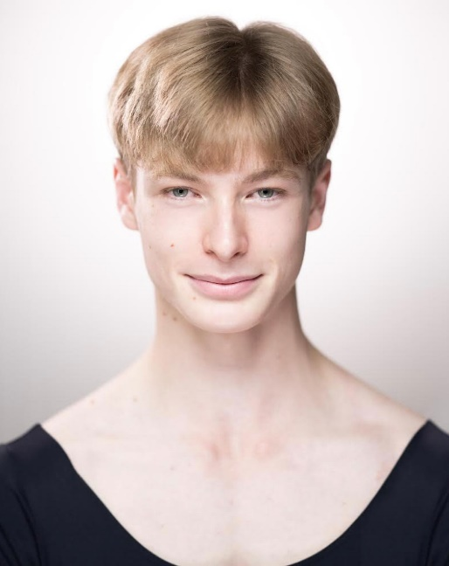  Profile  Height: 185cm  Weight: 71.8kg  Nationality: United States of America  Age: 19  Address: 46 Floral St, Covent Garden, London WC2E 9DA  EMAIL ADDRESS:  John.murch@student.royalballetschool.org.uk  PHONE NUMBER:  USA +1 (205) 569 3039  UK +44 7572 951953  HOBBIES  Traveling, photography, videography, painting, swimming, thrifting, Pinterest boards, and listening to music. | John Daniel Murch  EDUCATION  The Royal Ballet Upper School – The English style  [2021 – 2024]  The Rock School for Dance Education - Vaganova  [2019 - 2021]  Alabama Ballet - RAD  [2015 – 2018]  Boston Ballet Summer Intensive  [2021]  American Ballet Theatre Summer Intensive  [2016, 2017, 2018, 2019]  WORK EXPERIENCE  The Royal Ballet’s production of ‘Manon’  Choreographed by Kenneth MacMillan  [2024]  The Royal Ballet’s production of ‘The Nutcracker’  Choreographed by Sir Peter Wright  [2023 – 2024]  The Royal Ballet’s ‘Romeo and Juliet’ (tour to Japan)  Choreographed by Kenneth MacMillan  [2023]  Solo Evening Performance (The Royal Ballet School)  [2023]  Speaking Host for Summer Performance (The Royal Ballet School)  [2022]  Solo Evening Performance (The Royal Ballet School)  [2022]  YAGP Finalist  [2021]  YAGP 1st place (semi-finals)  [2021]  The Nutcracker Prince in ‘The Nutcracker’ (The Rock School for Dance Education)  Choreographed by The Rock School  [2019]  The Nutcracker Prince in ‘The Nutcracker’ (The Alabama Ballet)  Choreographed by George Balanchine  [2015 – 2017]

