Martina Travi
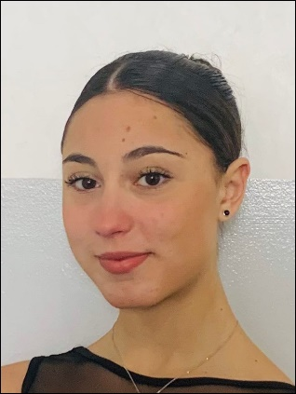
Born in Milan on 24/oct/2005
Nationality: Italian

Via Peppino franchi maggi 37,
20089, Rozzano (Milan),
Italy.

Mobile phone: +393489859688
Email: marty.travi@gmail.com

Gender: Female
Height:168 cm
Weight: 51 Kg
Language skills: Fluent English, Italian, Spanish, Portuguese.

Ballet Education/teachers:

2021 - until now:
Conservatório Internacional de Ballet and Dança Annarella Sanchez in Leiria (Portugal).
Ballet teachers Annarella Sanchez, Alexander Santana, Ely Regina Hernandez Numa.
Courses: Maina Gielgud, Yannick Boquin , Siner Gonec, Marta Iris Fernández.
Contemporary teacher Ricardo Flores, Enrique Pérez Cancio cantero.
Courses: Roberta Ferrara.

2019 - 2021:
Accademia Danza Milano in Milan
with the ballet teacher “Valentina Peschier” and the Contemporary teacher “Giorgio Azzone”.

2013 - 2019:
Ukrainian ballet academy in Milan (AUB)
where i studied classical dance, historical dances and character dances.

2011 - 2013:
I start studying classical dance at the Carcano theater school in Milan.

Professional training/work experience:

2023:
- Various Classical performances as a Corps de ballet , Duets and Soloist (Classical and Contemporary), for Conservatório Internacional de Ballet and Dança Annarella Sanchez and Junior CBCL.

2022:
- Member of the Junior Companhia de Ballet Classico de Leiria (CBCL).
In parallel with my studies at Conservatório Internacional de Ballet and Dança Annarella Sanchez.
- Corps de ballet in “Sleeping Beauty”, choreographer: Maina Gielgud.
Conservatório Internacional de Ballet and Dança Annarella Sanchez for Junior CBCL.
- Various Classical and Contemporary performances as a Corps de ballet , Duets and Soloist (Classical and Contemporary), for Conservatório Internacional de Ballet and Dança Annarella Sanchez and Junior CBCL.
- Various Classical and Contemporary competitions.

2021:
  - Corps de ballet in “Don Quixote”, choreographer: Maina Gielgud.
Conservatório Internacional de Ballet and Dança Annarella Sanchez in Leiria.
  - Various Classical and Contemporary competitions.

2020:
  - intensive course Ensemble Teen, with the company “Equilibrio dinamico”,
Artistic director: Roberta Ferrara. (Contemporary)

2017 – 2019:
  - With AUB at Arcimboldi Theater Milan:
“Le Corsaire” and “Nutcracker”
“Don Quixote” and “Snow-white and the Seven Dwarfs”
“Giselle” and “Snow-white and the Seven Dwarfs”

Martina Travi

