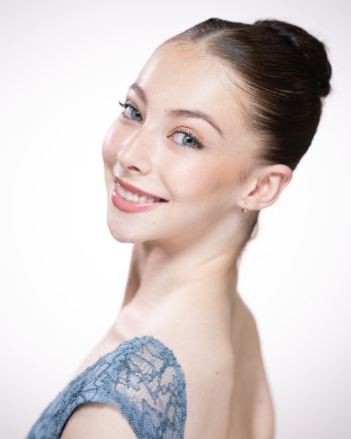
TIANIE-FINN
GRAINGER
ABOUT ME
I began dancing aged four and initially trained in musical
theatre and tap alongside ballet. I’ve always loved being
on stage in any capacity, however my passion grew for
ballet after becoming a Royal Ballet Junior associate at
the age of Eight. I then decided to dedicate my focus
more towards the classical direction. I love embodying
different roles and characters whilst challenging myself
technically. I feel very grateful to have found my true
love and vocation early in my life and hope to turn my
passion into a life long career.

EDUCATION
The Royal Ballet Upper School

2021-2024
The Royal Ballet School White
Lodge

2016-2021
The Royal Ballet Junior
Associates
2013-2016
PROFILE
Age;
18

Height
:
165cm
Nationality:
British

CONTACT
Mobile-
07561711795
Email address:
Tianie.Grainger@student.royalballetsch
ool.org.uk
Address-

46
Floral St, Covent
Garden, London, WC2E
9
DA

TIANIE-FINN
GRAINGER
WORK EXPERIENCE
2023
The Royal Opera House

T

Opera Holland Park
The Linbury Theatre

Performing:

The Nutcracker, Snowflake and Angel The Royal ballet Don Quixote core de ballet The Royal Ballet world ballet day live ‘’Rhapsody pas de deux’ Borne to dance gala, Banqueting house ‘Rhapsody pas de deux’

t

Grande defile

Don Quixote ‘Dream scene, small soloist~ Carlos Acosta

Four Seasons ~ Sir Kenneth Macmillan
Bold~ Goyo Montero

The Royal Opera House

Opera Holland Park
The Linbury Theatre - The Next Generation
Festival

Sadlers Wells Theatre- Unite for Ukraine gala
Buckingham Palace- The Queen's Platinum
Jubilee celebration
Performing
:

The Nutcracker
Grande defile
Pas de douze- Sir Frederick Ashton

Raymonda Chardaz - Rudolph Nureyev
2021
The Royal Opera House

Performing:

Grande defile
Swingle Stepping- Morgan Runnica-Temple

2022
2019
The Royal Opera House

Opera Holland Park
The Linbury Theatre

Performing:

The Nutcracker

Grande defile
Paquita Mazurka- Marinus Petipa

2018
The Royal Opera House

Opera Holland Park
Performing:
The Nutcracker

Grande defile
Little
Red
Riding
Hood-
Sleeping
Beauty-
Marius Petipa
2017
The Royal Opera House

Opera Holland Park
Performing:

The Nutcracker
Grande defile
Conservatoire
2016
The Royal Opera House

Performing:

The Nutcracker
TIANIE-FINN
GRAINGER
1
st place Lynn Seymour competition
Level 3 Nutrition course

Extended Qualification project

Kenneth MacMillan Emerging
choreographer

Royal Ballet School Ambassador

Community spirit award

Dame Ninette De Valois Emerging
choreographer

Commended choreography

2022
-
2021
-
2020
-

2020
-

2019
-
2017
-

ACHIEVEMENTS
Christopher Powney-

The Royal Ballet School Artistic Director
Email
-
Christopher.powney@royalballetschool.
org.uk
Mobile
- +44 (0)20 7845 7042
Address
46 Floral St, Covent Garden,
-
London WC2E 9DA
Jessica Clarke-

The Royal Ballet School Artistic
Manager
Email
-

Jessica.Clarke@royalballetschool.org.uk
Mobile
- +44 (0)20 7845 7042
Address
-
46 Floral St, Covent Garden,
London WC2E 9DA
REFERENCES

