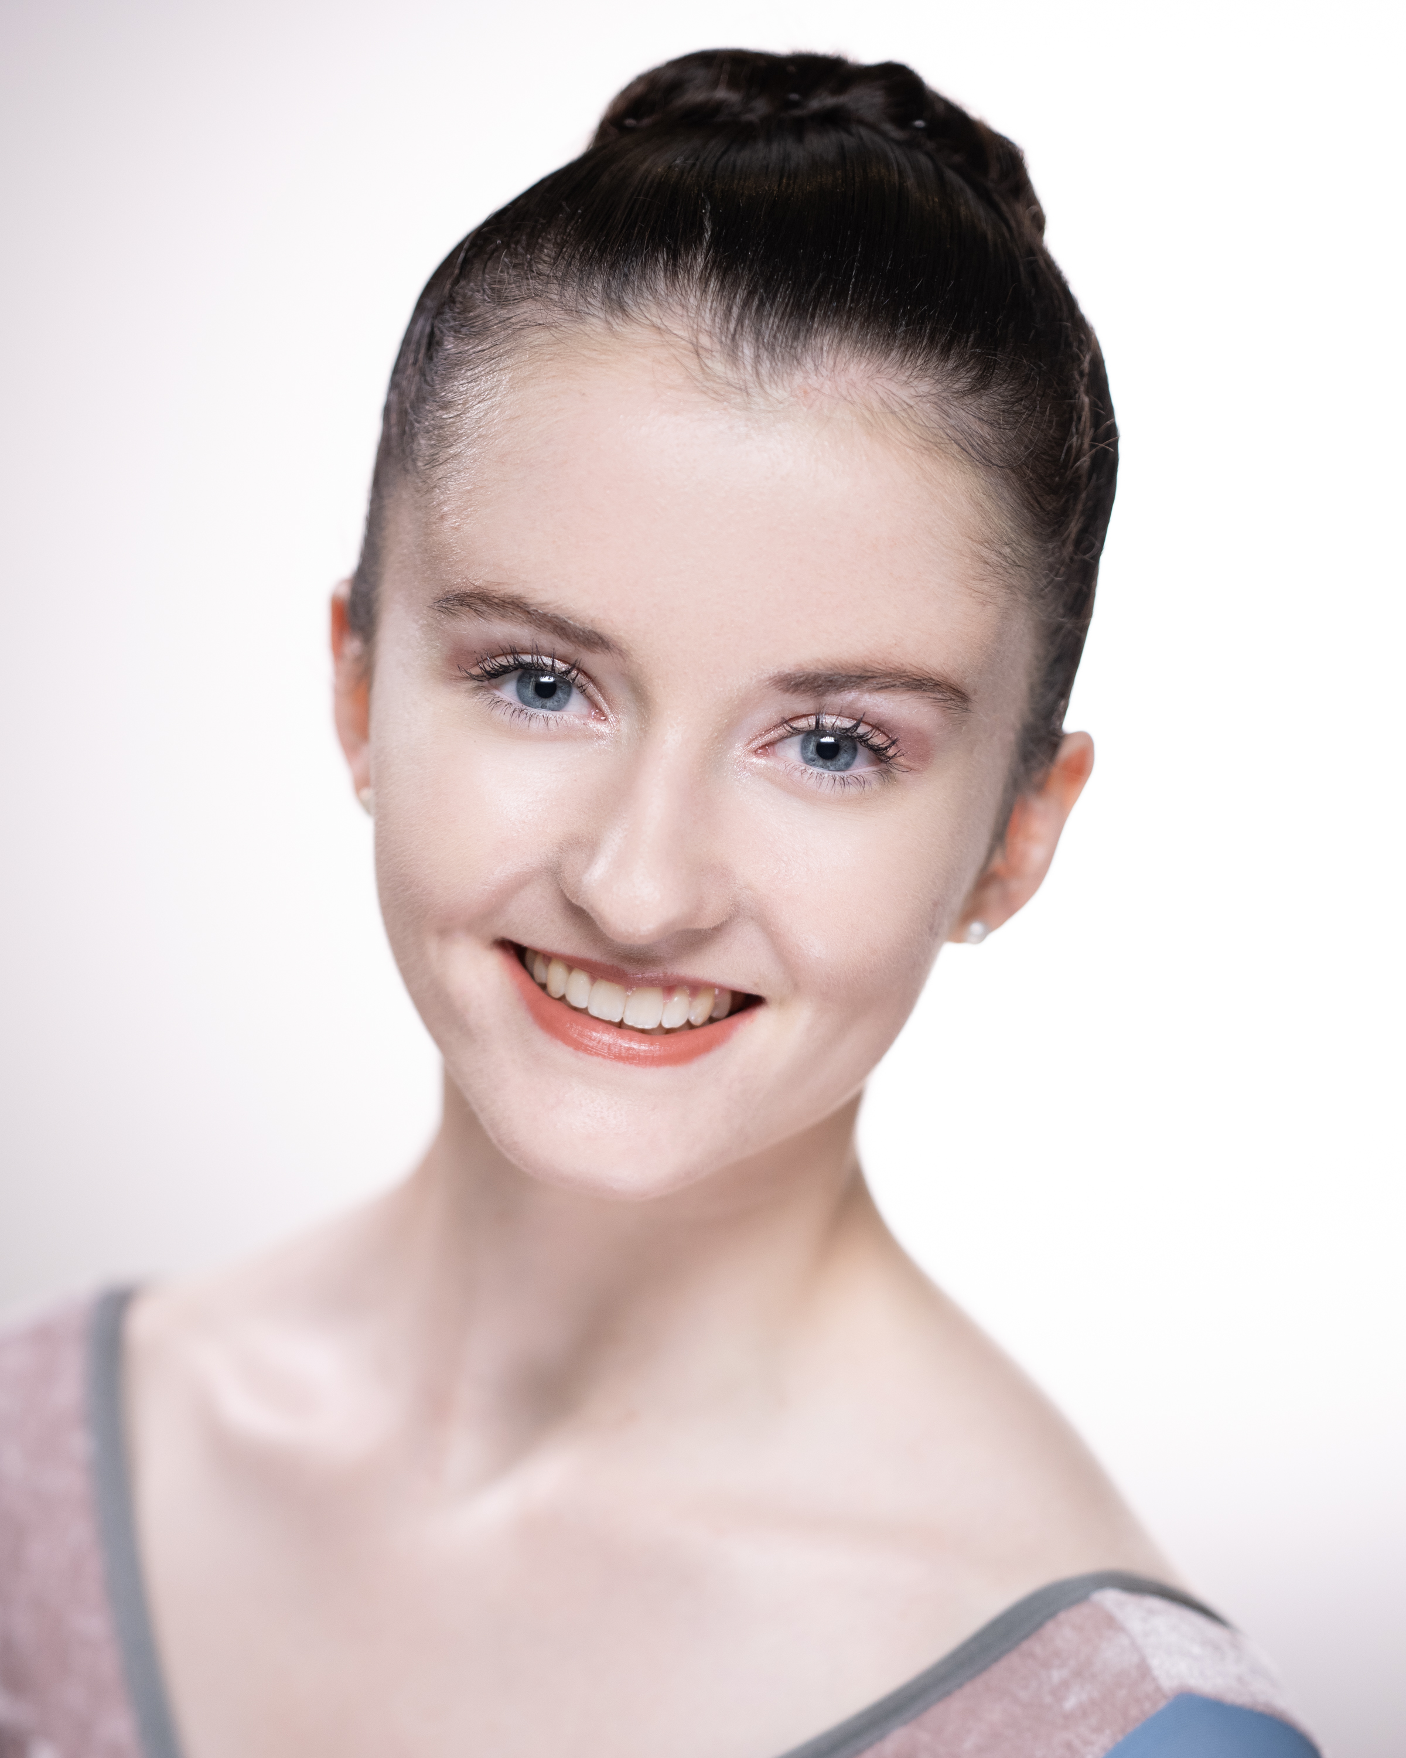
Victoria
Height:
174 cm
Nationality: British
DOB: 24/10/2002
Age:
21
Ellwood
+44 7928 892132
victoria.ellwood16@gmail.com

Training
Royal Ballet School Graduate 2022
Attended September 2014- April 2023

Professional work

Mergaliyev Classical Ballet 2024 tour as corps de ballet dancer, Big Swan and Lead Hungarian couple

Brecon Festival Ballet corps de ballet member 2023
Royal Ballet Giselle 2021 as a Willi
Royal Ballet Swan Lake 2022
Royal Ballet Nutcracker 2021, 2016, 2015
Royal Ballet School annual performances at ROH Covent Garden Main Stage and Linbury Theatre and Opera Holland Park

Work Experience
Created/ rehearsed with: Wayne McGregor, Didy Veldman, Liam Scarlett, Valentino Zucchetti, Zenaida Yanowsky, Daria Klimentová, Tamas Solymosi, Christopher Carr and more.
Reference
Daria Klimentová: @dariaklimentova on Instagram
Zenaida Yanowsky: zenaida.yanowsky@royalballetschool.org.uk
Christopher Powney: christopher.powney@royalballetschool.org.uk

