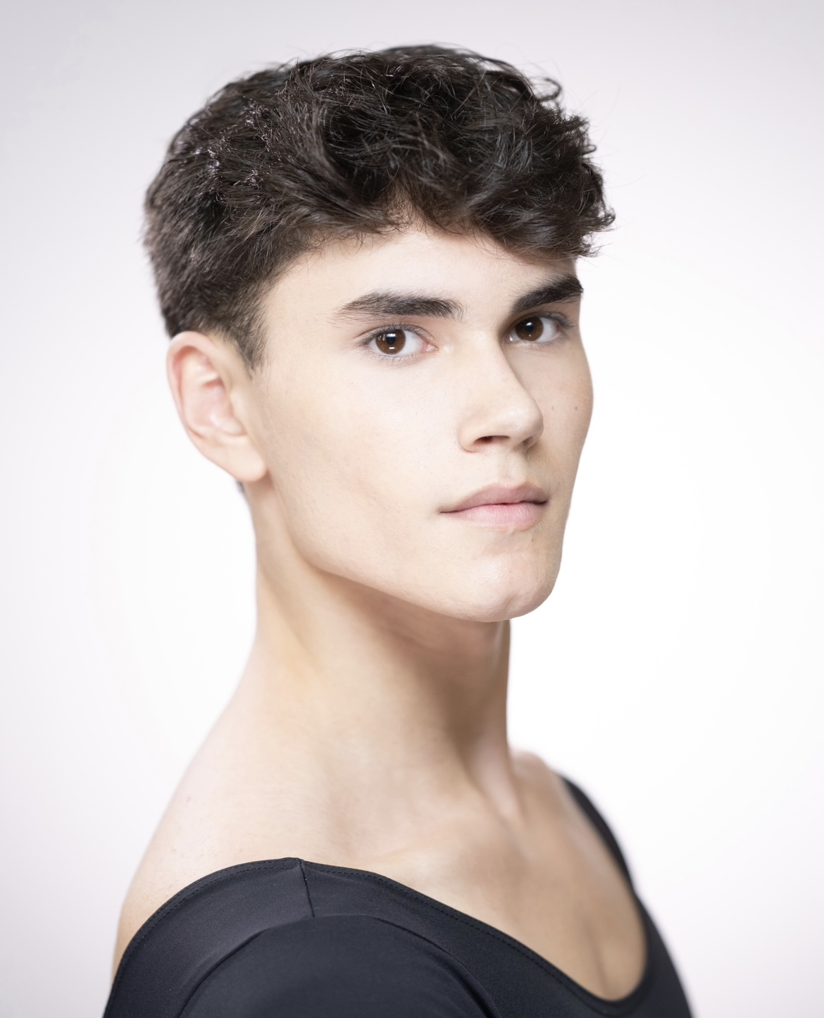 |  | Joe birtles clarke  The Royal Ballet School  EDUCATION
Profile  HEIGHT: 183cm  NATIONALITY: British  D.O.B: 30/08/2005  AGE: 18  CONTACT  PHONE NUMBER:  +44 07860607526  ADDRESS: 46 Floral St, Covent Garden, London WC2E 9DA  EMAIL ADDRESS:  Joseph.Clarke@student.royal  balletschool.org.uk |  |  | The Royal Ballet Upper School  2021 – Present  Currently in the Graduate Year  (Christopher Powney, Stuart Cassidy, Paul Lewis, Zhan Atymtayev)  The Royal Ballet School, White Lodge (Lower School)  2017- 2021  (Christopher Powney, Kenta Kura, Valeri Hristov, Zhan Atymtayev, Hope Keelan)  WORK EXPERIENCE  The Royal Ballet Company  Don Quixote, Wine Man, Shadow, The Royal Ballet,  The Royal Opera House 2023  Sentry, Tall Solider, Party Child in The Nutcracker, The Royal Ballet, The Royal Opera House, 2018 / 2019  Fritz, Small Soldier, Party Child in The Nutcracker, The Royal Ballet, The Royal Opera House, 2017 / 2018  The Royal Ballet School Performances  The Royal Ballet School Grande Defilé, The Royal Opera House, 2017, 2018, 2019, 2021, 2022, 2023  Opera Holland Park, The Royal Ballet School Summer Performance, 2017, 2018, 2019, 2021, 2022, 2023  Next Generation Performance. The Royal Ballet School  The Linbury Theatre, 2019, 2023  The Royal Platinum Jubilee Performance, Buckingham Palace, The Royal Ballet School, 2022  The Royal Opera House Performances with The Royal Ballet School:  BOLD, By Goyo Montero, 2023  Four Seasons By Kenneth McMillan, 2023  Raymonda, By Marius Petipa, 2022  Swingle Stepping, By Morgann Runacre-Temple 2021  Paquita, By Marius Petipa, 2019  Sleeping Beauty, Marius Petipa, Frederick Ashton, Anthony Dowell, 2018  Konservatoriet, By: Augustus Bournonville, 2017  Achievements  Artistic Prize for Progress and Endeavor, The Royal Ballet School – Christopher Powney, 2019  Artistic Prize for Progress and Endeavour, The Royal Ballet Upper school – Christopher Powney, 2023  Qualifications  The Royal Ballet School  2017 – present  BA Honours Degree in Classical Ballet and Dance Performance – Roehampton University, The Royal Ballet School  Cabin Crew Diploma  Extended Project Qualification (EPQ) - Grade B  7 x GCSEs: Dance, Drama, Combined Science, English Language, English Literature, Art, Maths.  other interests  I have a passion for drawing especially portrait and landscape work. I like to travel whenever I can as I enjoy exploring the world and in my free time, I love playing the cello as music is something I connect to a lot.  References  Christopher Powney  Artistic Director and CEO  46 Floral St, Covent Garden, London  Christopher.Powney@royalballetschool.org.uk  Stuart Cassidy  Ballet Teacher  46 Floral St, Covent Garden, London  Stuart.Cassidy@royalballetschool.org.uk

