Simon Kortmann
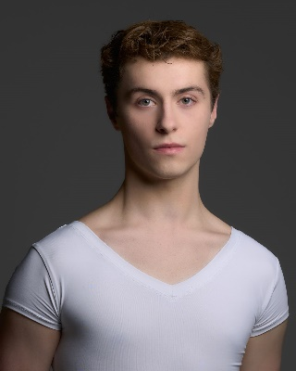
Personal information:
Simon Jan Michel Kortmann
Rapenburg 68a 1011TZ,
Amsterdam, The Netherlands

+31 06 28 54 83 53
simonkortmann58@outlook.com
09-04-2005
174cm / 5.7feet
Dutch
Dutch, French
Dutch, English, French

Full name :
Address :

Telephone :
E-mail :
Date of Birth :
Height :
Citizenship :
Nationality :
Language :

Ballet education:
Academic education:
Gerrit v.d. veen, Amsterdam
Degree: HAVO, 2022

Graduated 2022 Dutch National Ballet Academy, Amsterdam preliminary course
Currently in second year of Dutch National Ballet Academy, Amsterdam AD program

Extensive training in classical ballet
Teachers:
- Ernst Meisner
Additional courses in:
-Contemporary dance: Marion Vijn, Lia Witjes-Poole,
-Mental skills, tutoring: Marion Vijn
-Caractère: Grigori Tchitcherine
-World Dance: Iva Lešić
-Creative Dance: Lilja Hermannsdottir
-Pilates & Floor Barre: Leila Kester, Reina Trifunovic
-Body Conditioning: Jurgen Paulusma
-Dance history: Swantje Schäuble
-Music Theory Preliminary course/AD: Maud van Daal

- Grigori Tchitcherine
- Simona Ferrazza
- Laurence Korsenti
- Rinat Gizatulin
- Ainara Garcia-Navarro
- Emanouela Merdjanova
- Michele Jimenez
- Ryan Carroll
- Remi Wörtmeyer

Performances:
Some pieces danced in Dansers van Morgen
-unisono – Hans van Manen
-boléro – Jean-Yves Esquerre
-Poulenc suite – Ernst Meisner
-Paquita

Danced with Dutch National Ballet during:
-Swan Lake 2023
-Swan Lake 2019
-world premier Mata Hari 2016
-Nutcracker and the mouse King 2016
-Dansers Van Morgen 2016-2017-2018-2019-2021-2022-2023-2024

Participated in national and international summer schools:
- International ballet masterclasses Prague 2023
- Amsterdam international summer school 2022
- Amsterdam international online summer school 2020
- white lodge summer intensive 2019
- Dutch national ballet intensive 2018
- summer school Den Haag 2017

Workshops:
Educational project – Ducth national ballet
Contemporary solo – Didy Veldman
Contemporary piece – Ken Osola
Contemporary piece – Wubkje

References:
Teacher for 3+ years: Grigori Tchitcherine
Mail: Grigori.tchicherine@ahk.nl

School director and teacher Ernst Meisner
Mail: Ernst.meisner@ahk.nl
Phone number +31205277823

