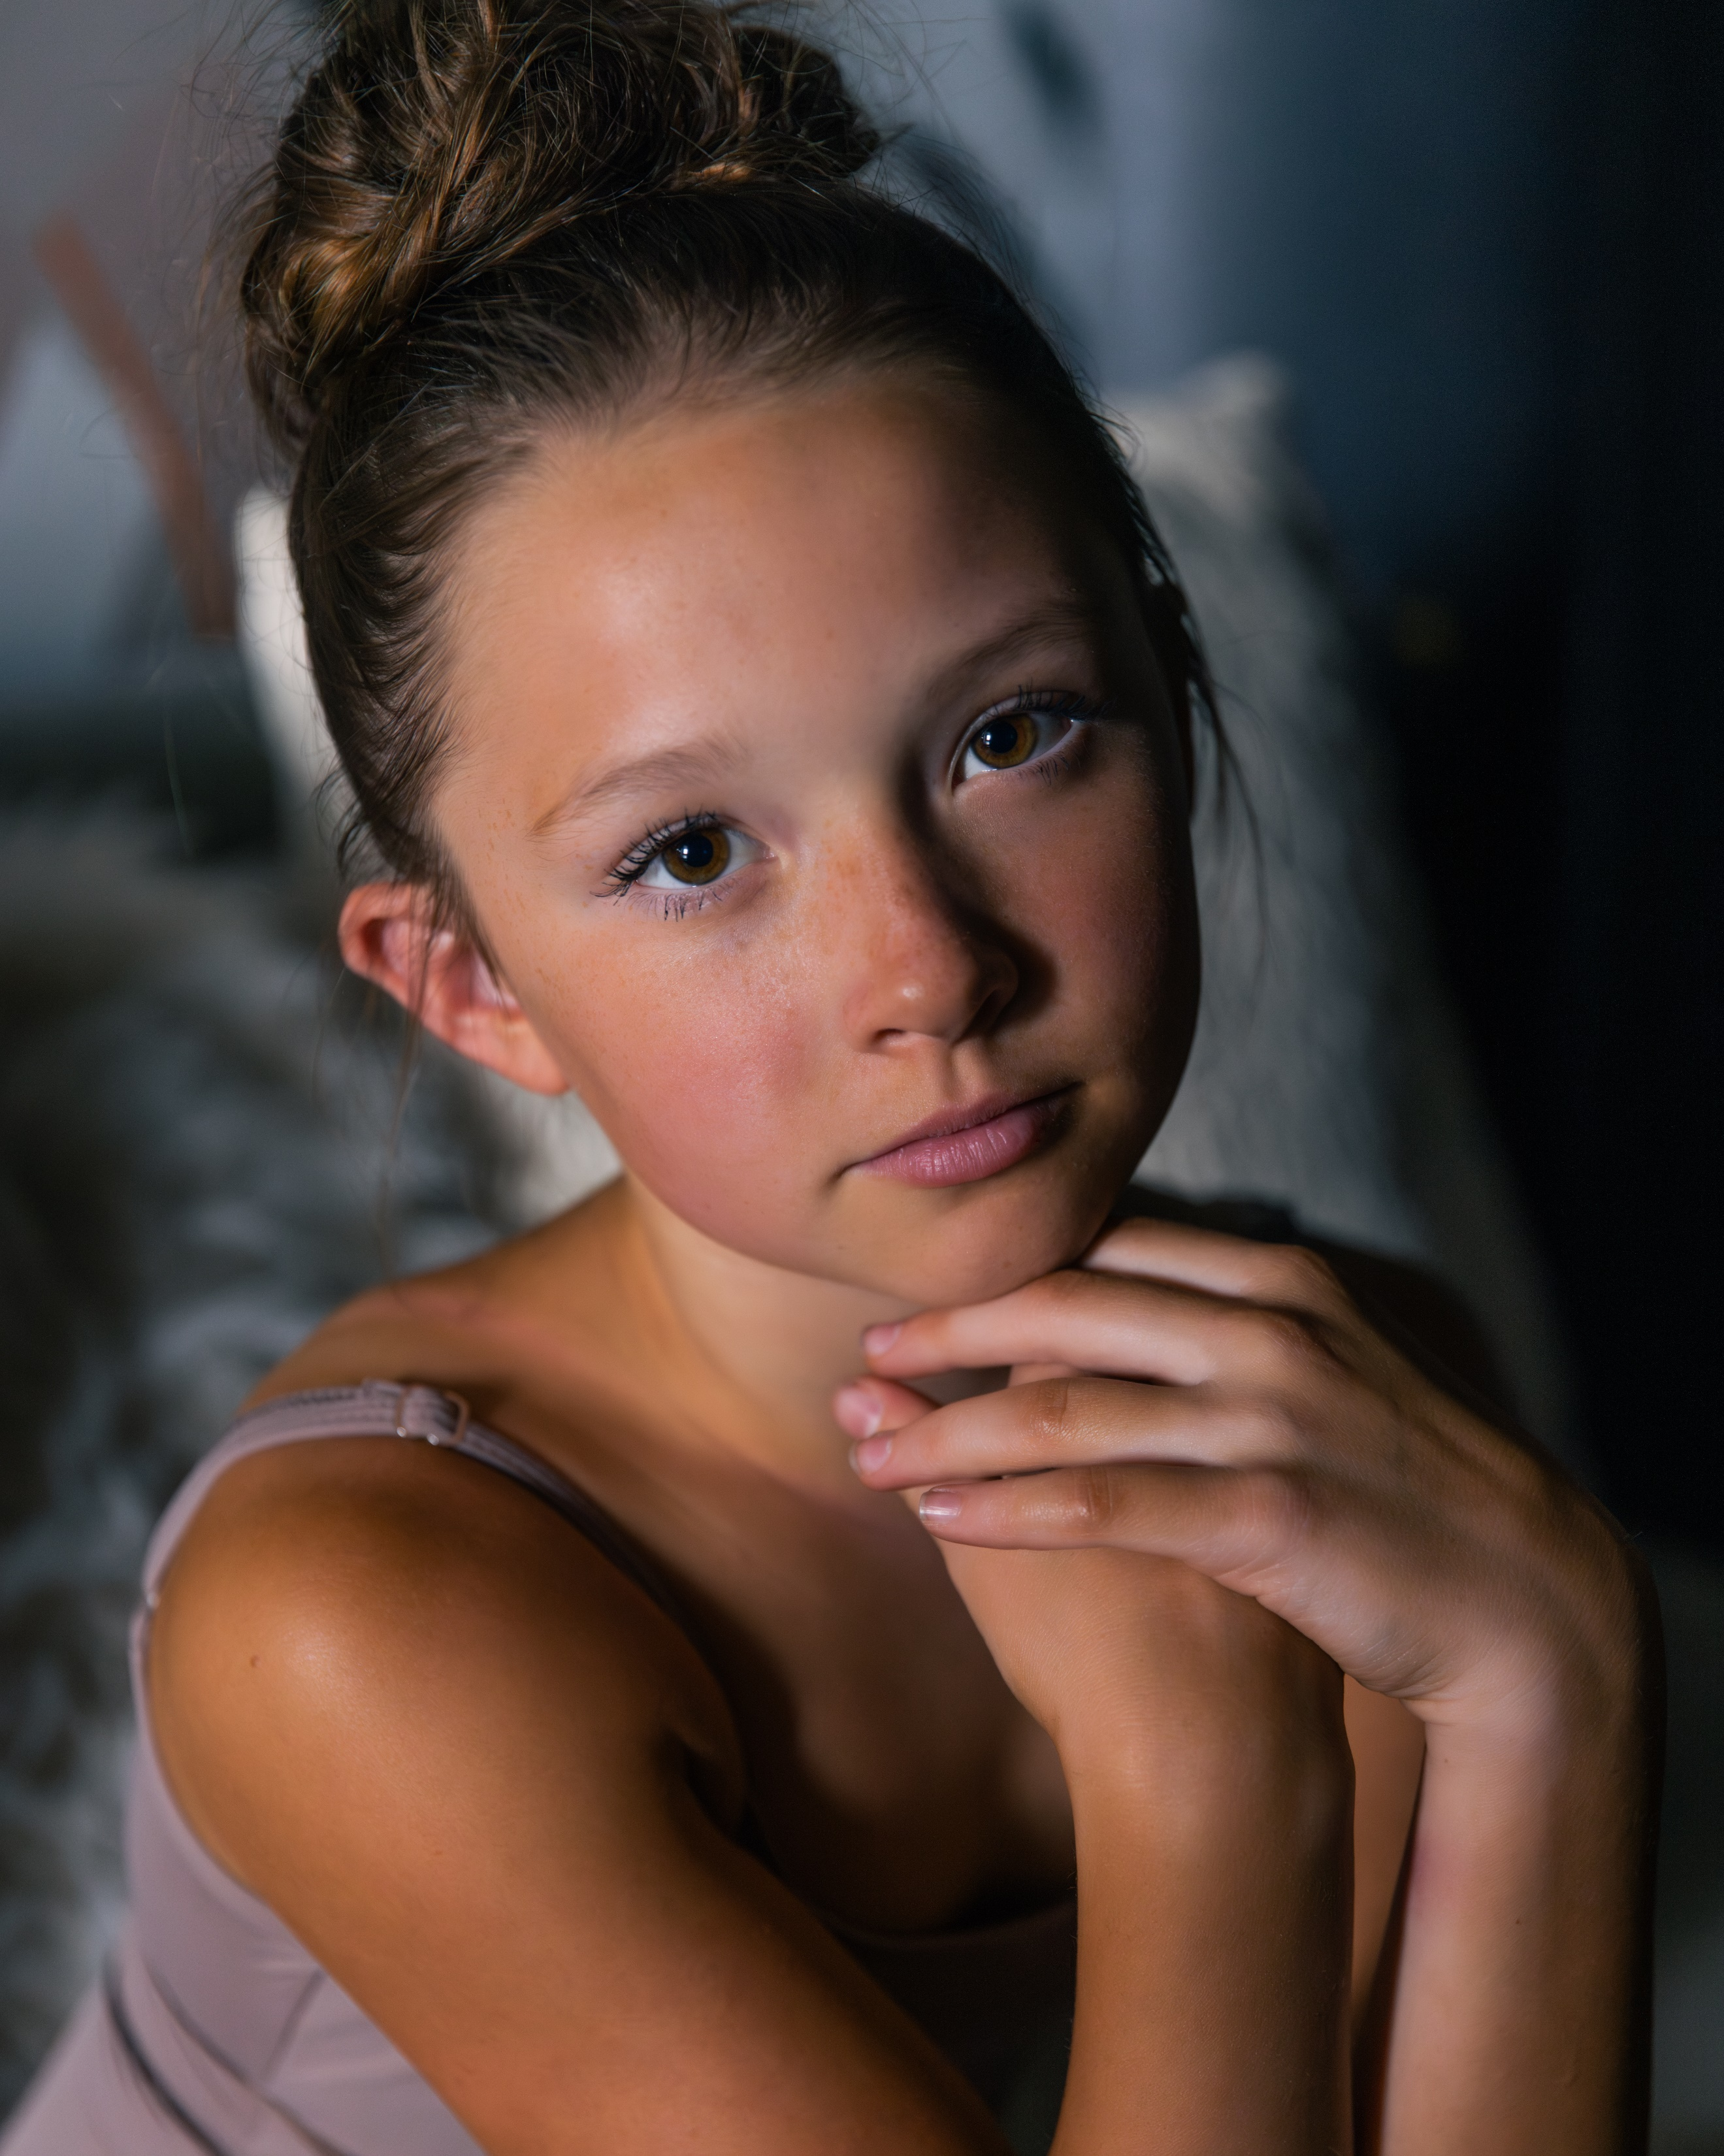  Physical Characteristics  Age:12  Height: 5’1”  Weight: 85 lbs  Contact  PHONE:  701-367-9378  Instagram: @harpsterjoy  EMAIL:  Kassi_n@hotmail.com  Training  25+ Hours Total Per week  - Ballet Technique  - Pointe  - Variations  - Contemporary  - Conditioning  - Modern  - Pilates  - Classical & Contemporary Privates  - Competition Soloist |  | HARPER  ANDERSON  Dance Training  Concept Pavielle  June 2020 – Present  Summer Intensive-2024,2023  School of American Ballet  5 week Summer Intensive- 2024  Elite Classical Coaching  Summer Intensive 2024  Winter Intensive 2023  Larkin Dance Studio  May 2017 – July 2023  A&A Ballet  Summer Intensive- 2023  Short Term- Jan 2023  Winter Intensive-2022  Ballet Academy East  Summer Intensive- 2022  The Ballet Clinic  Summer Intensive- 2022  Awards  YAGP Finals 2024,2023, 2022  YAGP Hope Award 2023  YAGP 1st Place classical, 1st place contemporary 2024,  YAGP 1st Place classical, 2nd place contemporary 2023  YAGP 2nd place classical, 3rd place contemporary 2022  Universal Ballet Competition 1st place classical & contemporary-2024, 2023  Universal Ballet Competition- Rising Star Award-2024, 2023  Universal Ballet Competition- Grand Prix 1St place classical & contemporary 2023  Universal Ballet Competition- Grand Prix Rising Star- 2023  The Dance Awards top 10 Mini 2023, 2022  Scholarships  Berlin State Ballet School- Short term  Alberta Ballet School- Short term and summer intensive  Viticca Ballet School-Summer Intensive  Joffrey Ballet School- Summer Intensive  Europeon School of Ballet- Summer Intensive  The Rock School for Dance Education-Summer Intensive  Oklahoma City Ballet-Summer Intensive

