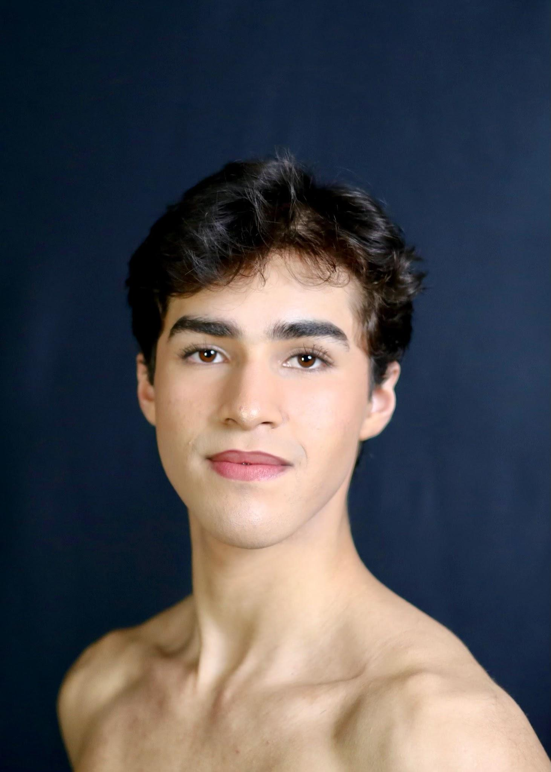
Sergio Suarez

Personal Details

DOB: March 25, 2004 Height: 5’8”
Nationality: Colombian
Visa Status: Eligible for US Working Visa, Currently on b-2 Visa
Home Address: Calle 41a #66a-95
Phone Number: +1 (772) 400-7310 E-Mail: sergio25suarezb@gmail.com Instagram: @ser.regio0

Training

Cary Ballet Conservatory (Cary, NC)
2023-present
Instructors: Mariaelena Ruiz, Heather Iler, Matthew Donnell, Agustin de Sousa, Sam Taylor, Beth Costigan

St. Lucie Ballet (Florida, FL)
2019-2022
Instructors: Rogelio Corrales, Lydia Oquendo

Compañía Colombiana de Danza (Colombia, Bogotá)
2017-2019
Instructor: Alicia Cajiao, Jairo Lastre

Performance and Experience

Jill Bahr’s “Alice in wonderland” Cast and set by Jill Bahr (2024)
Role: Mad Hatter

George Balanchine’s “Who Cares?” Cast and set by Jenifer Ringer and James Fayette (2024)
Roles: Liza Men’s solo (“Who cares” Pas de deux and five couples)

Cary Ballet Company’s “Coppelia” (2023)
Roles: Franz, Franz friends

Cary Ballet Company’s “The Nutcracker” (2022-2023)
Notable roles: Cavalier, Nutcracker, Russian lead, Party dad
St. Lucie Ballet “The Nutcracker” (2021)
Notable roles: Snow king, Mechanical doll, Marzipan Pas de deux, Party parent

Interviewed by Amy Brandt for Pointe Magazine “The Crucial Differences Between a Company and School Audition” (2023)

Competition Results

ADCIBC (2022-present)
Raleigh Semi-finals 1st place classical and 5th place contemporary (2024)
Raleigh Semi-finals 2nd place Pas de deux division (2024)
St. Petersburg finals Top 10 (2023)
Atlanta Semi-finals 4th place classical and 5th place contemporary (2022)
Atlanta Semi-finals 2nd place Pas de deux division (2022)
St. Petersburg finals 1st place classical highest scoring solo in senior division (2022)
St. Petersburg finals 3rd place classical Pas de deux (2022)

YAGP (2020-present)
Winston-Salem Semi-finals 3rd place classical and top 6 contemporary (2024)
Nashville Semi-finals 2nd place classical (2023)
Nashville Semi-finals 2nd place Pas de deux division (2023)
Orlando Semi-finals 2nd place classical and 2nd place contemporary (2022)
Orlando Semi-finals 2nd place Pas de deux division (2022)
Atlanta Semi-finals 1st place Pas de deux division (2022)
Boca Raton Semi-finals 1st place classical and top 12 contemporary (2021)
Boca Raton Semi-finals 3rd place contemporary Pas de deux (2021)
Finals invitations: 21’ 22’ 23’ 24’

UBC (2020-2022)
Jacksonville Grand prix finals 1st place classical Pas de deux division (2023)
Jacksonville Grand prix finals 11th place classical competitive (2023)
Atlanta Semi-finals 1st place classical Pas de deux (2022)
Miramar Semi-finals 2nd place classical Pas de deux (2022)
Miramar Semi-finals 3rd place classical Pas de deux (2021)
Miramar Semi-finals 2nd place classical and 5th place contemporary (2021)
Miramar Semi-finals 3rd place contemporary Pas de deux (2020)
Miramar Semi-finals 3rd place classical Pas de deux division (2020)
Miramar Semi-finals 1st place classical intermediate (2020)

