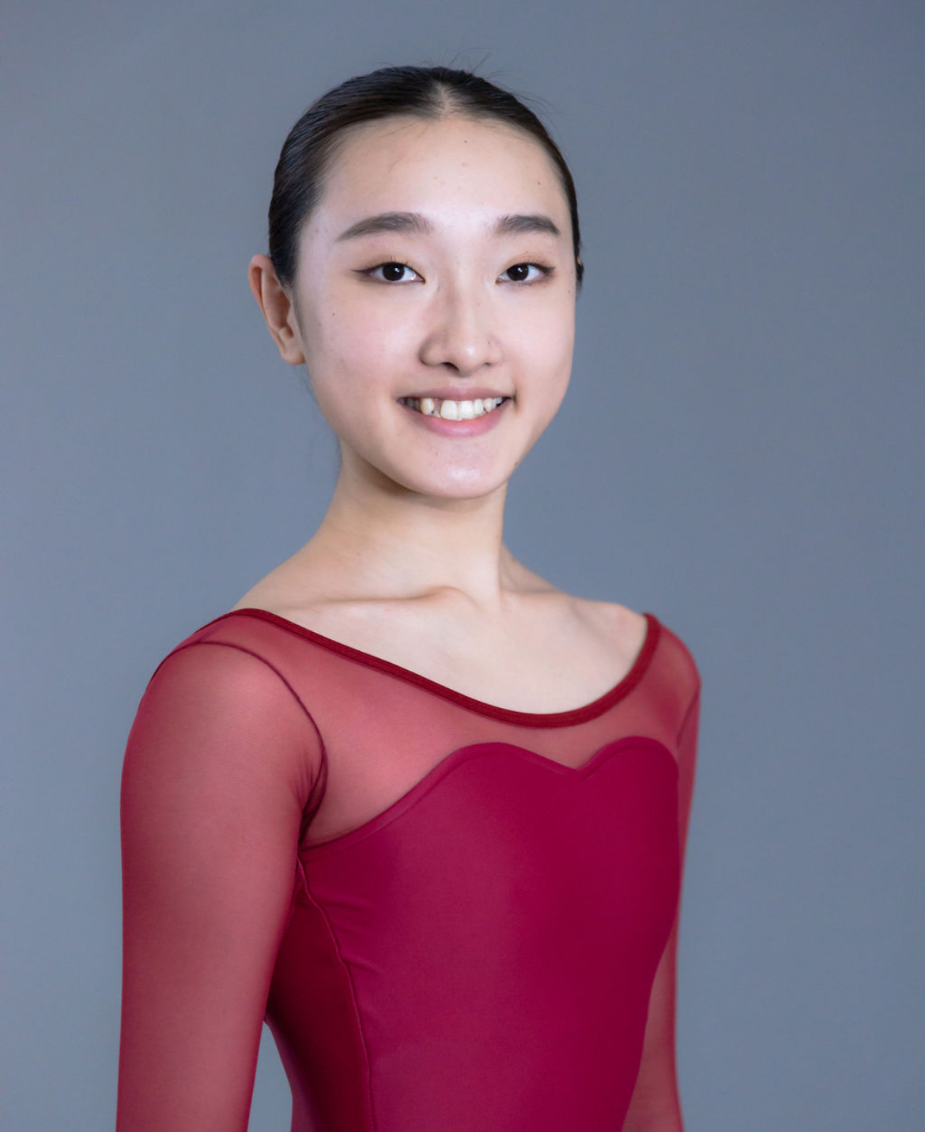
Sayaka Iwase

c/o The HARID Conservatory
2285 Potomac Road, Boca Raton, FL 33431
Telephone: +81-80-9101-6582
E-mail: ballet0809sayaka@gmail.com

Date of Birth: 08/09/2004 Height: 162cm Weight: 49kg Citizenship: Japan

Dance Training
2021–present: The HARID Conservatory, Gordon Wright, Director
Full tuition scholarship
Ballet, pointe, variations, partnering, repertoire, modern, jazz, character, Spanish, Pilates, nutrition, kinesiology
Teachers: Victoria Schneider, Alexey Kulpin, Meelis Pakri, Svetlana Osiyeva, (ballet); Lauren Carey (modern); Bertha Valentin (character); Rosa Mercedes (Spanish dance); Dennis Lue (jazz)

2019-2020: Yuriko Ballet Studio, Yuriko Tanoue, Teacher
Ballet, pointe, contemporary

2008–2018: Kumamoto Ballet, Seiko Ban, Teacher
Ballet, pointe

Summer Programs
2022: American Ballet Theatre, Kate Lydon, Director

2021: The HARID Conservatory, Gordon Wright, Director
Tuition and housing scholarship

2019: Colorado Ballet Academy, Erica Fischbach, Academy director
Tuition scholarship
Teachers: Domenico Luciano, Jayne Persch, Amanda McKerrow (ballet, point, variations)

Performance Experience (recently limited by the pandemic)
2023: The Nutcracker, Act II – Grand Pas de Deux, (staged by S. Osiyeva and M. Pakri)
Cinderella – Winter fairy (staged by Yuriko Tanoue)
La Bayadère – Jug dance (staged by Victoria Schneider)
Banjara (choreography by Mark Godden)
2022: Excerpt from Don Quixote – Kitri’s friend (staged by Alexey Kulpin)
2021: La Bayadere – Gamzatti (staged by Sayaka Karasugi)
2020: Giselle – Corps (staged by Yuriko Tanoue)
2017: The Nutcracker, Act I – Clara (staged by Seiko Ban)
Don Quixote, Act II – Cupid

Awards and Honors
2022: HARID Dance Study Award

References
Gordon Wright, director, The HARID Conservatory 561-997-2677; gordon.wright@harid.edu
Svetlana Osiyeva, ballet teacher, The HARID Conservatory 561-997-2677; svetlana.osiyeva@harid.edu

