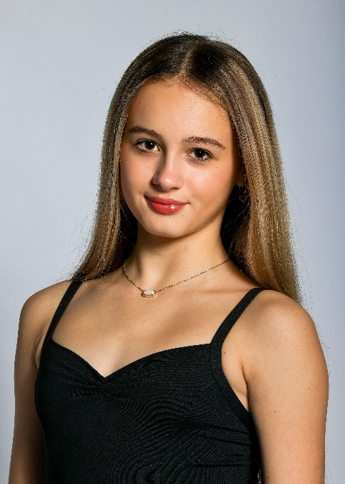 |  |  |  |  | Phoebe Ingram  Training  Indiana Ballet Conservatory 2014-Present  Summer: Dallas Conservatory SI 2021&, Chautauqua Institution Dance SI 2022, The Rock School for Dance Education 2023-Scholarship récipient  I currently train under the direction of Alyona Yakovleva-Randall, Tatiana Pali, and Roman Nikiforov for classical ballet in the Vaganova training method. Contemporary instructors include Sergey Sergiev and Brook Napier. I take 12+ hours of ballet technique and pointe weekly. I also train in modern/contemporary and character dance. My training is approx 22 hours weekly.  Perormance  Indiana Ballet Conservatory’s Nutcracker 2015-2023  Notable roles  Clara 2021/2022, Columbine 2023, Pas De Trois 2022, 2023,  Entre Media Doll 2019/2020  Fairy Doll 2022 -Notable Role -French Doll  competition  2024 YAGP 2nd Place Contemporary& Classical  2024 NYCDA 9th Place  2023 YAGP 1st place Classical, 2nd Place Contemporary  2023 NYCDA 5th Place  2022 YAGP Int’ Finals Tampa- 3rd Place Contemporary  2022 YAGP Indianapolis -1st Place Classical  2022 YAGP Chicago- 1st Place Contemporary, 2nd Place Classical  2022 ADC|IBC Int’ Finals – 4th Place Overall  2022 ADC|IBC Pittsburgh- 1st Place Contemporary/1st Place  Classical  2022 NYCDA Nashville- 6th Place  2021 YAGP Finals- Top 12 Contemporary  2021 YAGP Indianapolis- Hope Award  2021 YAGP Chicago -1st Place Classical, 2nd Place Contemporary  2020 YAGP Indianapolis-3rd Place Classical  2020 YAGP Atlanta- Top 12 Contemporary
317-441-2365
@Phoebegreyingram
Age 13
7/9/2010
Height 5’2





