
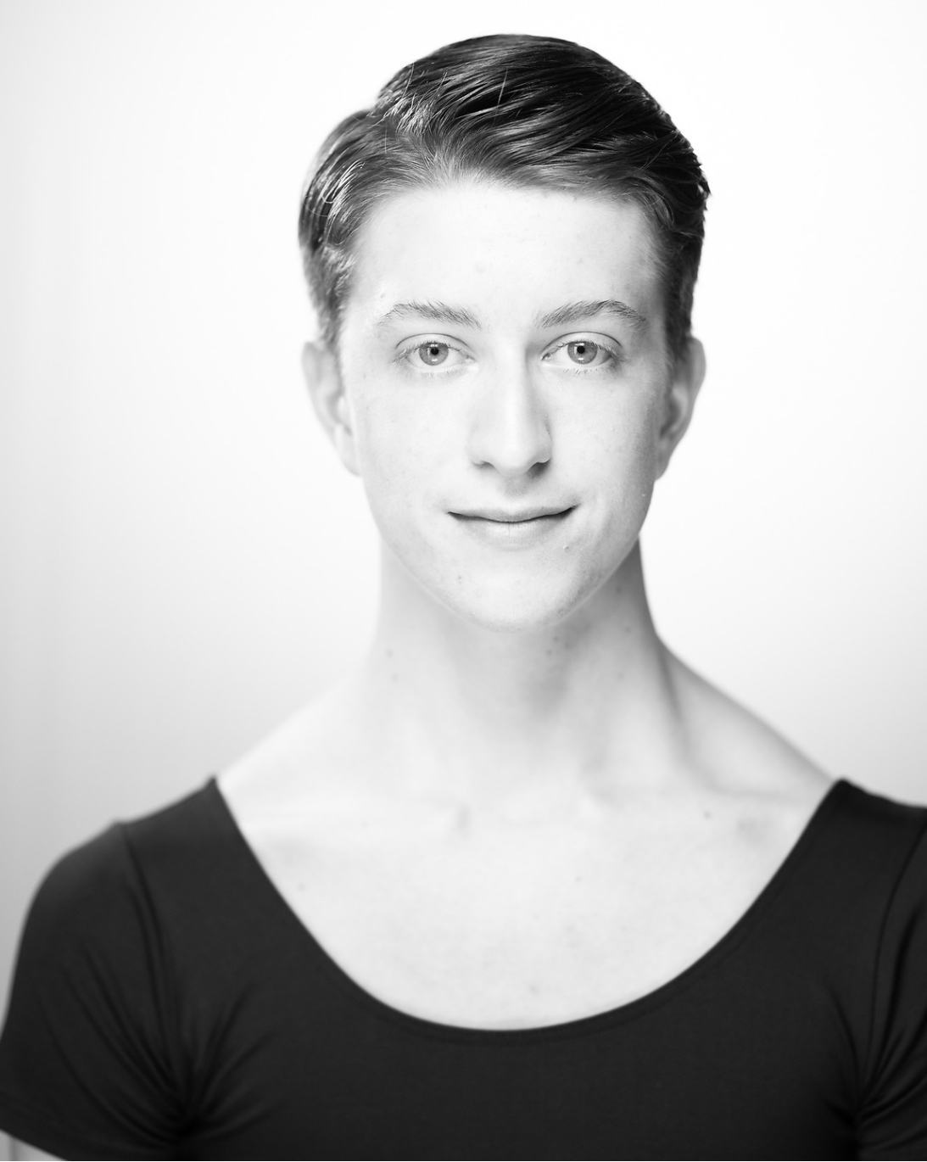 |  | EDOARDO SAVINI  The Royal Ballet School
Profile  HEIGHT: 183 cm  NATIONALITY: Italian  D. O. B.: 16/04/2005  AGE: 18  Contact  PHONE:  +44 7379836721  ADDRESS:  46 Floral Street, Covent Garden, London, WC2E 9DA  EMAIL:  edosav90@gmail.com  REFERENCES:  Christopher Powney (Artistic Director and CEO)  Christopher.Powney@royalballetschol.org.uk  Jessica Clarke (Artistic Manager)  Jessica.Clarke@royalballetschool.org.uk  Stuart Cassidy (Most recent Teacher)  Stuart.Cassidy@royalballetschool.org.uk |  | EDUCATION  The Royal Ballet School:  -Upper School  2021 – Present  Currently in Graduate Year  (Christopher Powney, Stuart Cassidy, Paul Lewis, Zhan Atymtayev)  -White Lodge (Lower School)  2019 - 2021  (Christopher Powney, Valerie Hristov, Kenta Kura)  WORK EXPERIENCE  Royal Ballet Company 2023-2024  -Don Quixote  The Royal Ballet School Grand Defile  2023  -Bold (Goyo Montero)  -Four Seasons (Kenneth Macmillan)  -Fast Blue (Michela Polley)  2022  -Raymonda (Marius Petipa)  -Pas de Douze, Swan Lake (Frederick Ashton)  2021  -Swingle Stepping (Morgann Runacre Temple)  Opera Holland Park performances (2021-2023)  Unite for Ukraine gala – Pas de Douze, Swan Lake (2022)  Linbury performances (2022, 2023)  -Next generation festival performances  Queen’s Platinum Jubilee (2022)

Achievements
2017- Youth American Grand Prix (YAGP) Top 6, Paris Semi-finals
2016- Youth American Grand Prix (YAGP) Top 12, New York Finalist

ACademic education

BA Hons Classical Dance and Dance Performance (2021-present)

Roehampton University

A-level (2021-2023)

Maths (A)

GCSE’s (2019-2021)

-Dance Studies (9)

-Music (9)

-Maths (9)

-Further Maths (9)

-Science (9-9)

Skills

As a disciplined and dedicated dancer, I constantly strive to put in a lot of effort in both classes and rehearsals.I am very resilient and always excited about tackling new challenges. Working and communicating with people and other dancers and choreographers is something I enjoy doing very much. In addition, I have a passion for travel, which I believe aligns perfectly with the company touring side.

