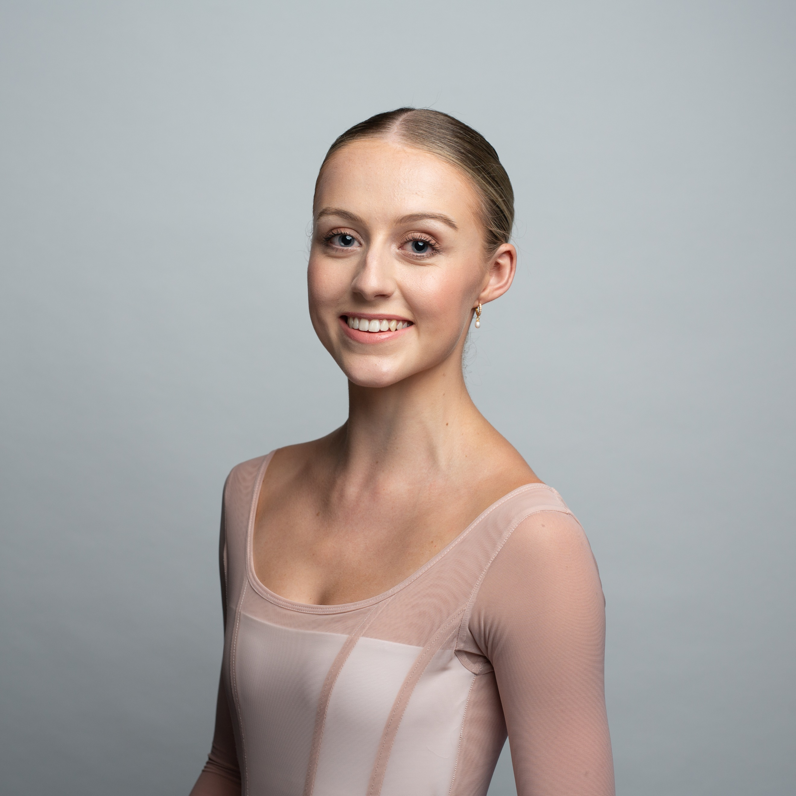  Profile  Name: Alyssa Park  Age: 20  Date of Birth: 22/01/2004  Citizenship: Australian  Height: 161cm  Weight: 47kg  Hair Colour: Blonde  Eye Colour: Blue  Contact  ADDRESS:  Unit 10804/405 Montague Rd, West End QLD 4101  PHONE:  +61(0)400496308  EMAIL:  alyssalouisepark@hotmail.com  References  Greg Horsman  GHorsman@queenslandballet.com.au  Jillian Vanstone  jillian.vanstone@gmail.com  Matthew Lawrence  Mlawrence@queenslandballet.com.au  Paul Boyd  pboyd@queenslandballet.com.au  Claire Phipps-Males  cphipps@queenslandballet.com.au  Grant Aris  garis@queenslandballet.com.au  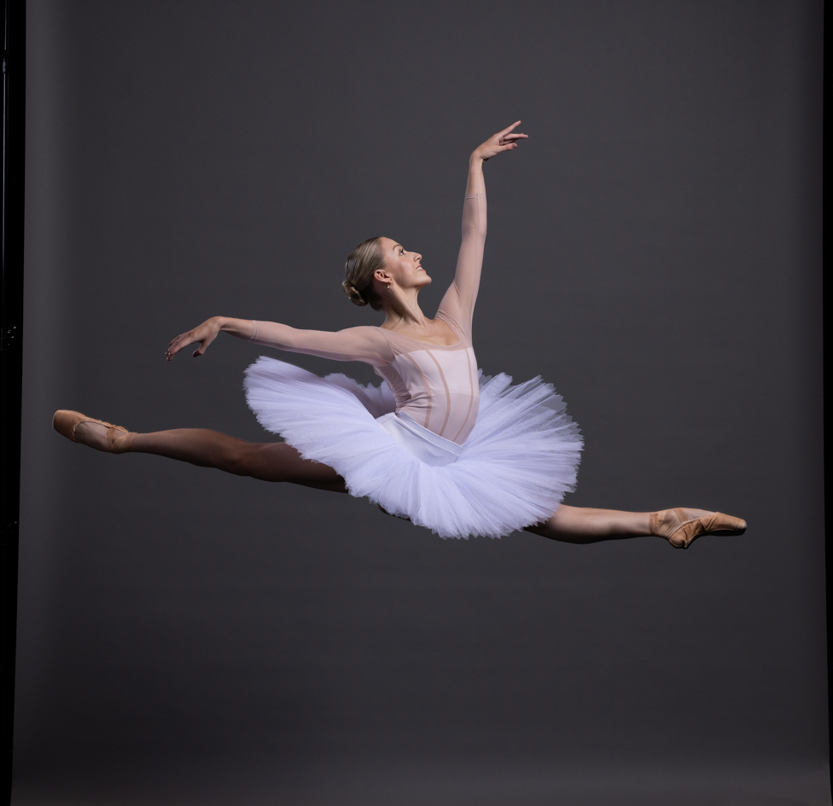  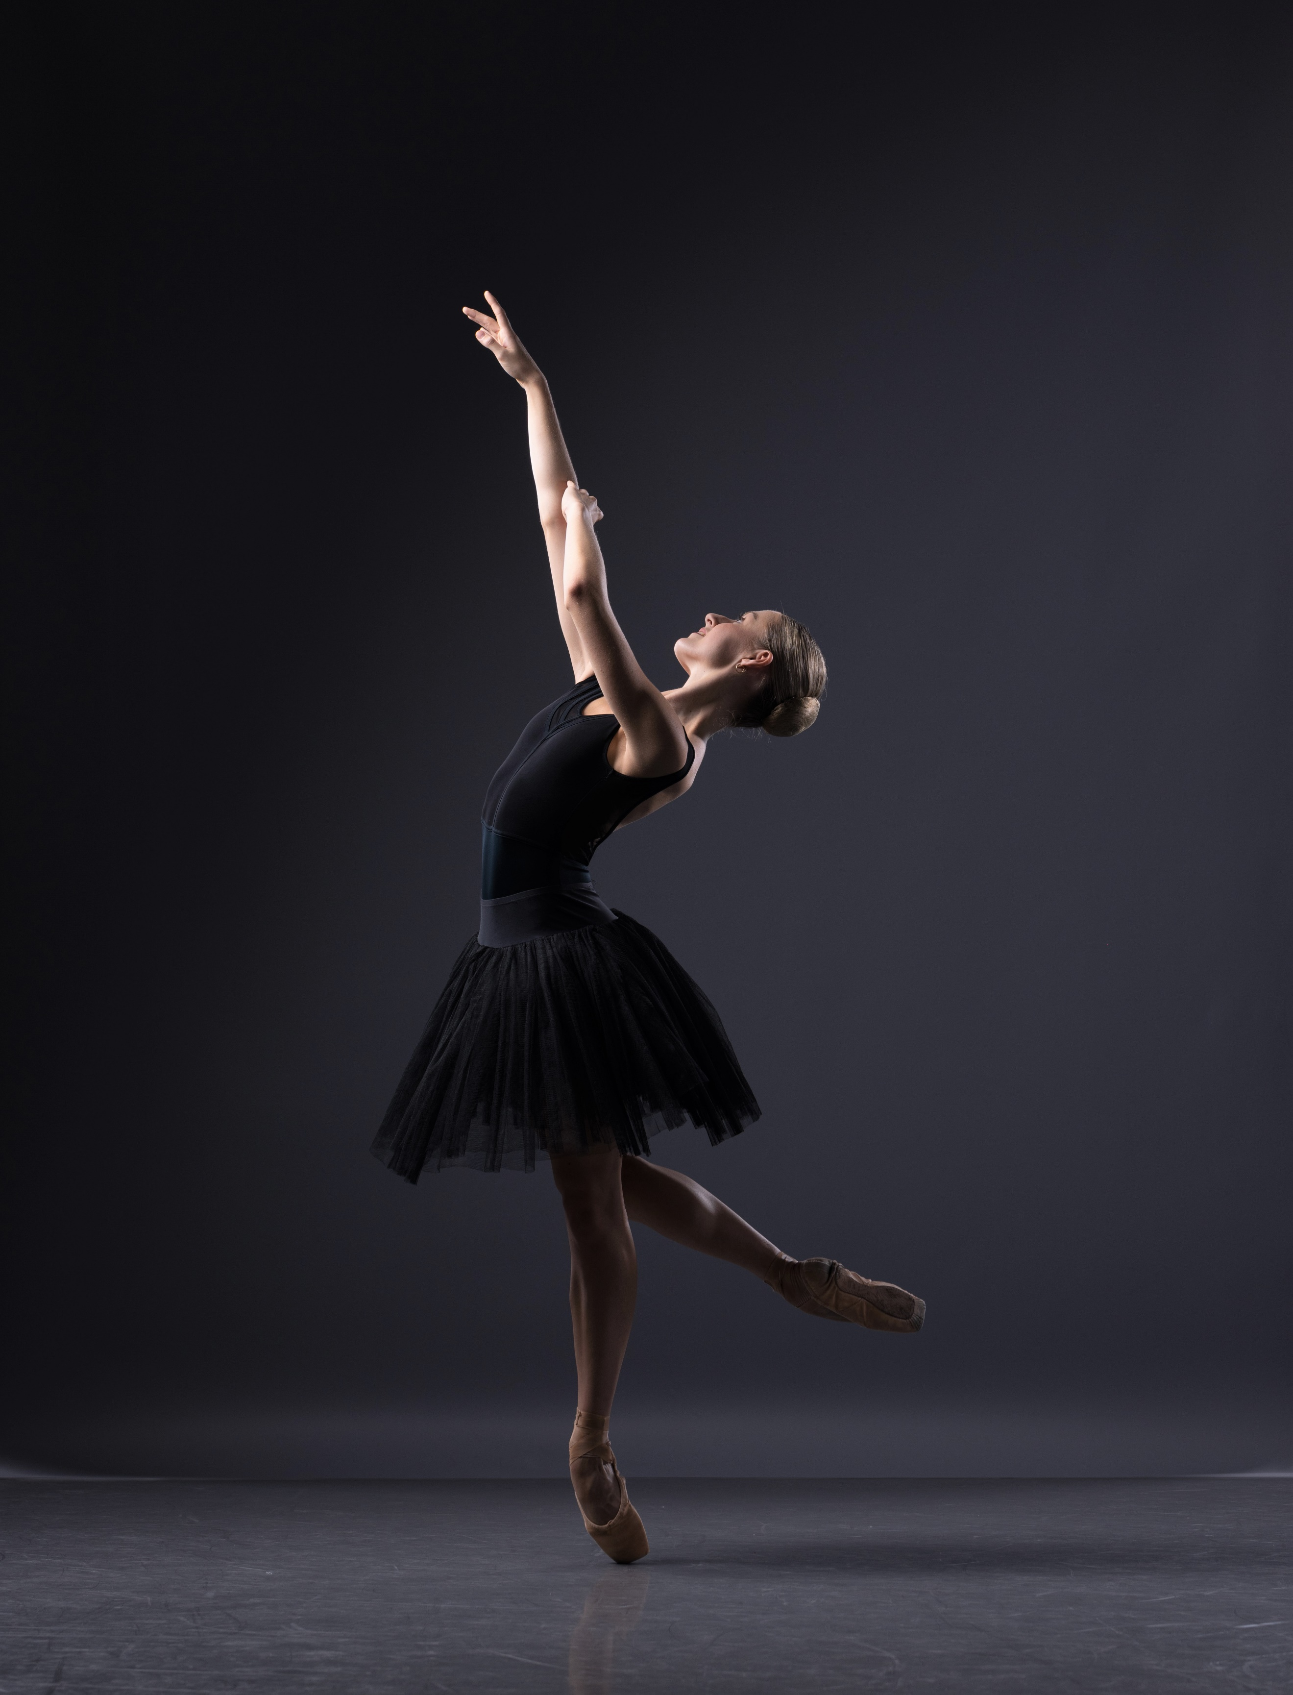  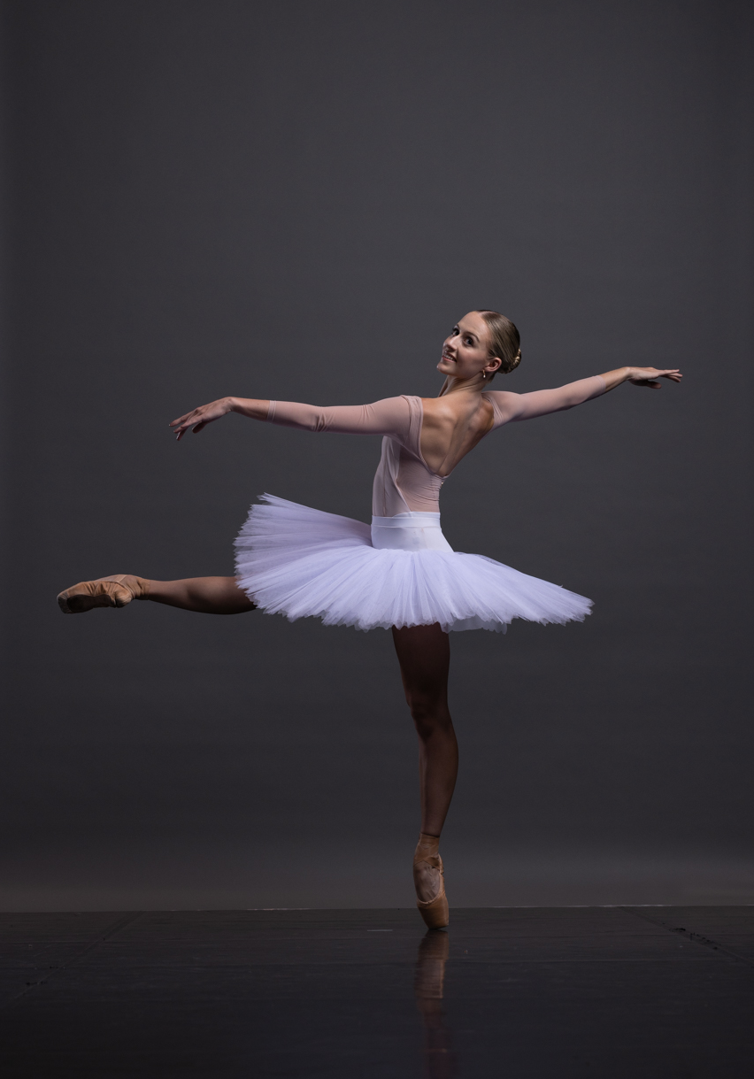 | Alyssa Park  Professional Experience  Queensland Ballet, Artistic Director Greg Horsman (Previously Leanne Benjamin (2024) and Li Cunxin (2012-2023):  (2024) Queensland Ballet Jette Parker Young Artist  - Papillon, choreography Jack Lister  - Holberg Suite, choreography Greg Horsman- Principal Lady  - Cinderella: My First Ballet, choreography Ben Stevenson OBE, staged by Matthew Lawrence- Cinderella, Fairy Godmother and corps de ballet roles  - Colossus, choreography Stephanie Lake- featured performer  (2023)  - The Nutcracker, choreography Ben Stevenson OBE- Flower, Snowflake, Parent, Rat and Cook  (2022)  - Manon, choreography Sir Kenneth MacMillan- Beggar and Harlot  - Peter and the Wolf, choreography Greg Horseman- Bird and Scout  (2015-2018)  - The Nutcracker, choreography Ben Stevenson OBE- supernumerary roles  Performance experience  Queensland Ballet Academy:  (2023)  - Le Nouveau Classique, choreography Paul Boyd- Principal Lady  - Penned, choreography Paul Boyd- The Poet  - Swarm, choreography Grant Aris- Lead Pas De Deux  - The Poetic Tantrums, choreography Amelia Waller- corps de ballet  - Chaplin excerpt, choreography Mario Schroeder- corps de ballet  (2022)  - The Voyager, choreography Natalie Weir – Backpack Pas De Deux and Lead Flower  - Williow, choreography Natalie Weir- Main Pas De Deux  - Le Nouveau Classique, chorography Paul Boyd- Soloist  - Holberg Suite, choreography Greg Horsman - Principal Lady  - Mil Besos, choreography Amelia Waller - corps de ballet  - A Twist of Broadway, choreography Paul Boyd – Soloist  (2021)  - Echo of Reflection, choreographed by Paul Boyd  - Diaspora, choreography Louise Deleur  (2020)  - The Nutcracker-Waltz of the Flowers, choreography Ben Stevenson OBE  - The Little Humpbacked Horse, Frescoes, choreography Arthur Saint-Léons  - Borders, choreography Louise Deleur  (2019)  - Les Sylphides, choreography Marius Petipa – corps de ballet  - Napoli, Tarantella, choreography August Bournonville  - Marcha, choreography Louise Deleur  Ballet Theatre of Queensland:  (2017)  - Les Sylphides-Nocturne, choreography Mikhail Fokine – corps de ballet  - Alice in Wonderland excerpt, choreography Timothy Brown- March Hare  - The Nutcracker- Dance of the Mirlitons, choreography Timothy Brown- corps de ballet  - Coppelia excerpt, choreography Timothy Brown-Swanhilda’s Friends  (2016)  - Aladdin, choreography Timothy Brown- corps de ballet  (2015)  Sleeping Beauty, choreography Timothy Brown- corps de ballet  Dance education:  (2022-2023) Queensland Ballet Academy Pre-Professional Program  (2019-2021) Queensland Ballet Academy Upper School  (2017-2018) Atelier Australia  (2007-2018) Dance Diversity  Further Training:  (2018) Australasian Dance Collective Youth Ensemble  (2015-2018) Australian Ballet School’s, Interstate Training Program  Awards and recognition:  (2020/2021) Queensland Ballet Academy, Training Scholarship  (2016) Ballet Theatre of Queensland, Phyllis Danaher Memorial Scholarship  Academic Education:  (2021) Diploma of Business  (2019-2021) Certificate of Education, Kelvin Grove State College  (2016-2018) Palm Beach Currumbin State High School

