To do what ?
- To improve your daily life: stress management, transient anxiety, sleep disorders, learning difficulties, professional or personal change, self-confidence, stimulation of creativity...
- With a view to or during medical treatment: pain management, depression, fibromyalgia, cancer, multiple sclerosis, participation in recovery, management announcement of a diagnosis… IN PARALLEL WITH MEDICAL FOLLOW-UP.
- For behavioral disorders: phobias, impulses, addictions, bulimia, anorexia, agoraphobia, claustrophobia… IN PARALLEL WITH MEDICAL FOLLOW-UP.
- For mental preparations: exams, stage preparation, childbirth, IVF, driving license, pro interviews, speaking...
For who ?
For ALL because sophrology adapts to the constraints linked to all ages and all trades.
HARMONY OF BODY AND MIND


I LOVE SOPHRO

Playful Sophro – Ericksonian hypnosis –

Mindfulness

Specialities : sport, teenagers, children, seniors, campanies, cancer, perinatal

What is sophrology?

To do what ?

For who ?

How ?

In what form ?

What is it ?
A mix of eastern and western techniques (hypnosis, neurology, autosuggestion, relaxation, zen, bouddhism, yoga, psychology…) implemented by a neuropsychiatrist Alfredo Caycedo, in Spain, in 1960.

DEVELOP BETTER SELF-KNOWLEDGE

How ?
Through controlled breathing techniques, muscle relaxation and positive visualization.

In what form ?
In the form of simple static or dynamic exercices, easy to reproduce at home and which meet everyone’s needs and objectives. Personalized exercices.
In group or individually.

And the playful Sophro pedagogy ?
Pedagogy allowing a playful and practical approach. It includes body, consciousness, movement and creativity.

And the Ericksonian Hypnosis ?
Gentle technique allowing to circumvent the resistances, to reach the unconscious. Unlike Sophrology, here the body is separated from the mind. The HE is not in the WHY? But in the HOW, as for the Sophrology

And the Mindfulness?
Mindfulness meditation is good for your mind, changes our brain. The observations made on Bouddhist monks are astonishing : hours of meditation have an effect on the structure of their brain, reducing the areas linked to stress, and stimulating those involved in the regulation of emotions.
Can be practiced regardless of location or conditions.

BRIEF THERAPIES AND PERSONAL DEVELOPMENT

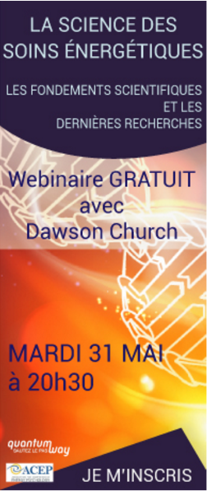
Même si l’EFT produit des résultats remarquables, il est toujours au stade expérimental. Ainsi, les praticiens et le public doivent assumer leur entière responsabilité lors de l’utilisation de cette technique. Si vous voulez avoir des renseignements sur l’application de l’EFT pour un problème émotionnel ou physique particulier, adressez vous à un praticien confirmé ou un professionnel reconnu de la santé mentale. Si nécessaire, consultez un médecin qualifié et formé à l’EFT.

Newsletter
Haut du formulaire
Bas du formulaire
Haut du formulaire
Inscription désinscription
Bas du formulaire

L'EFT, une version émotionnelle de l'acupuncture à la portée de tous
L’EFT permet d’atténuer les douleurs physiques et émotionnelles de manière rapide sans devoir nécessairement prendre des médicaments ou utiliser des aiguilles d’acupuncture. L’EFT vous permet également de passer outre les croyances et modèles mentaux habituels vous empêchant d’évoluer. Généralement, l’EFT agit là où toute autre technique échoue !

ACCEDER À UNE PRISE DE CONSCIENCE

I LOVE SOPHRO
Is a professional trained by IFS Paris, certified RNCP and member of the Chambre Syndicale de la Sophrologie practicing his profession in compliance with the code of ethics of the profession
Email : Ilovesophro@gmail.com

How :
Via Skype : maristef75

