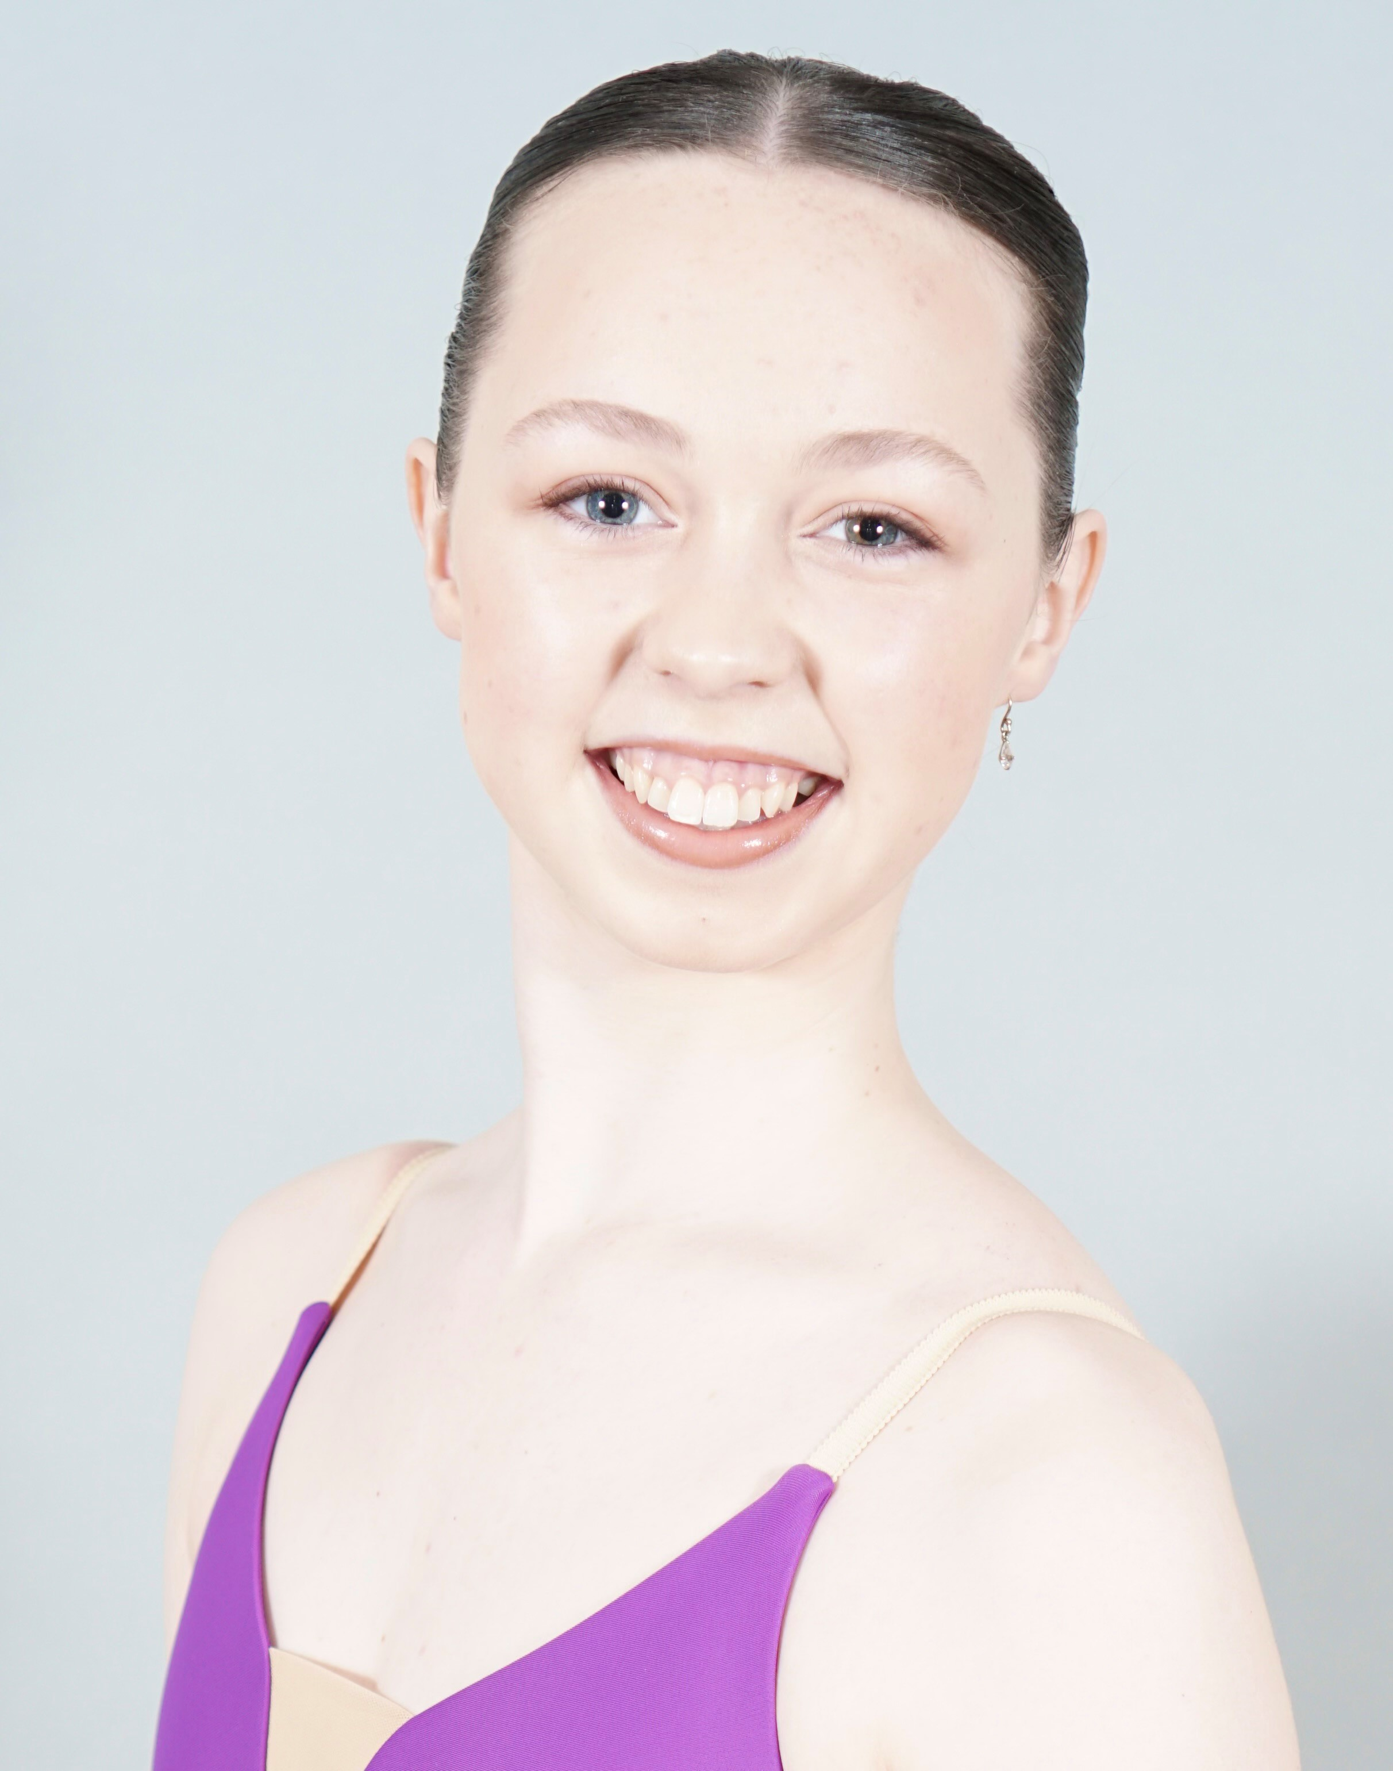 |  | Makenzee alora maree speak
Contact  Date of Birth: 10/10/2007 – 16 years old  Height: 169cm  Address: PO Box 376 Yandina QLD Australia 4561  Nationality: Australian  Languages: English  EMAIL:  sandra.humphreys@bigpond.com (parent)  mspeakballet@gmail.com (student)  PHONE:  (parent) +61 0409 467 586  (student) + 61 0436 436 040  WHATS APP:  mspeakballet@gmail.com  INTERESTS:  Reading  Art  Music |  | EDUCATION  Prima Youth Classical Academy – Artistic Director Kaytlyn Bell-Blissner  Jan 2022 - Current  Full-Time Classical Training Program.  Classes - Classical – Contemporary – Conditioning – Pilates.  Teachers - Mr Grant Aris, Ms Amelia Waller, Ms Kaytlyn Bell-Blissner & Ms Jessica Cove.  Syllabus - RAD & Borovansky examinations.  Achievements - High Distinction & Honours.  Previously Trained – Sunshine Coast Conservatory Of Dance  01/01/2012 – 31/12/2021  Commencement of ballet training in a recreational setting. All genres experienced. Inaugural student of “Excellence in Classical Training” Program with Marie Walton-Mahon OAM for 2021.  ADDITIONAL TRAINING  Australian Ballet ITP Levels 1-4  Jan 2017 – Dec 2022  Queensland Ballet Academy Guest Associate Program  Jan 2019 – Dec 2022  John Cranko Summer Intensive USA 2024  Received from YAGP Sydney Australia Semi Final 2023  Australian Institute of Classical Dance Awards 2023  Received 4th Place Senior Dancer  PERFORMANCE EXPERIENCE  Qld Ballet Nutcracker Children Cast Member  Brisbane City Youth Ballet – Ms Janine White Youth Ballet Company  Riley Baldwin Corp Instruction – Contemporary Youth Company  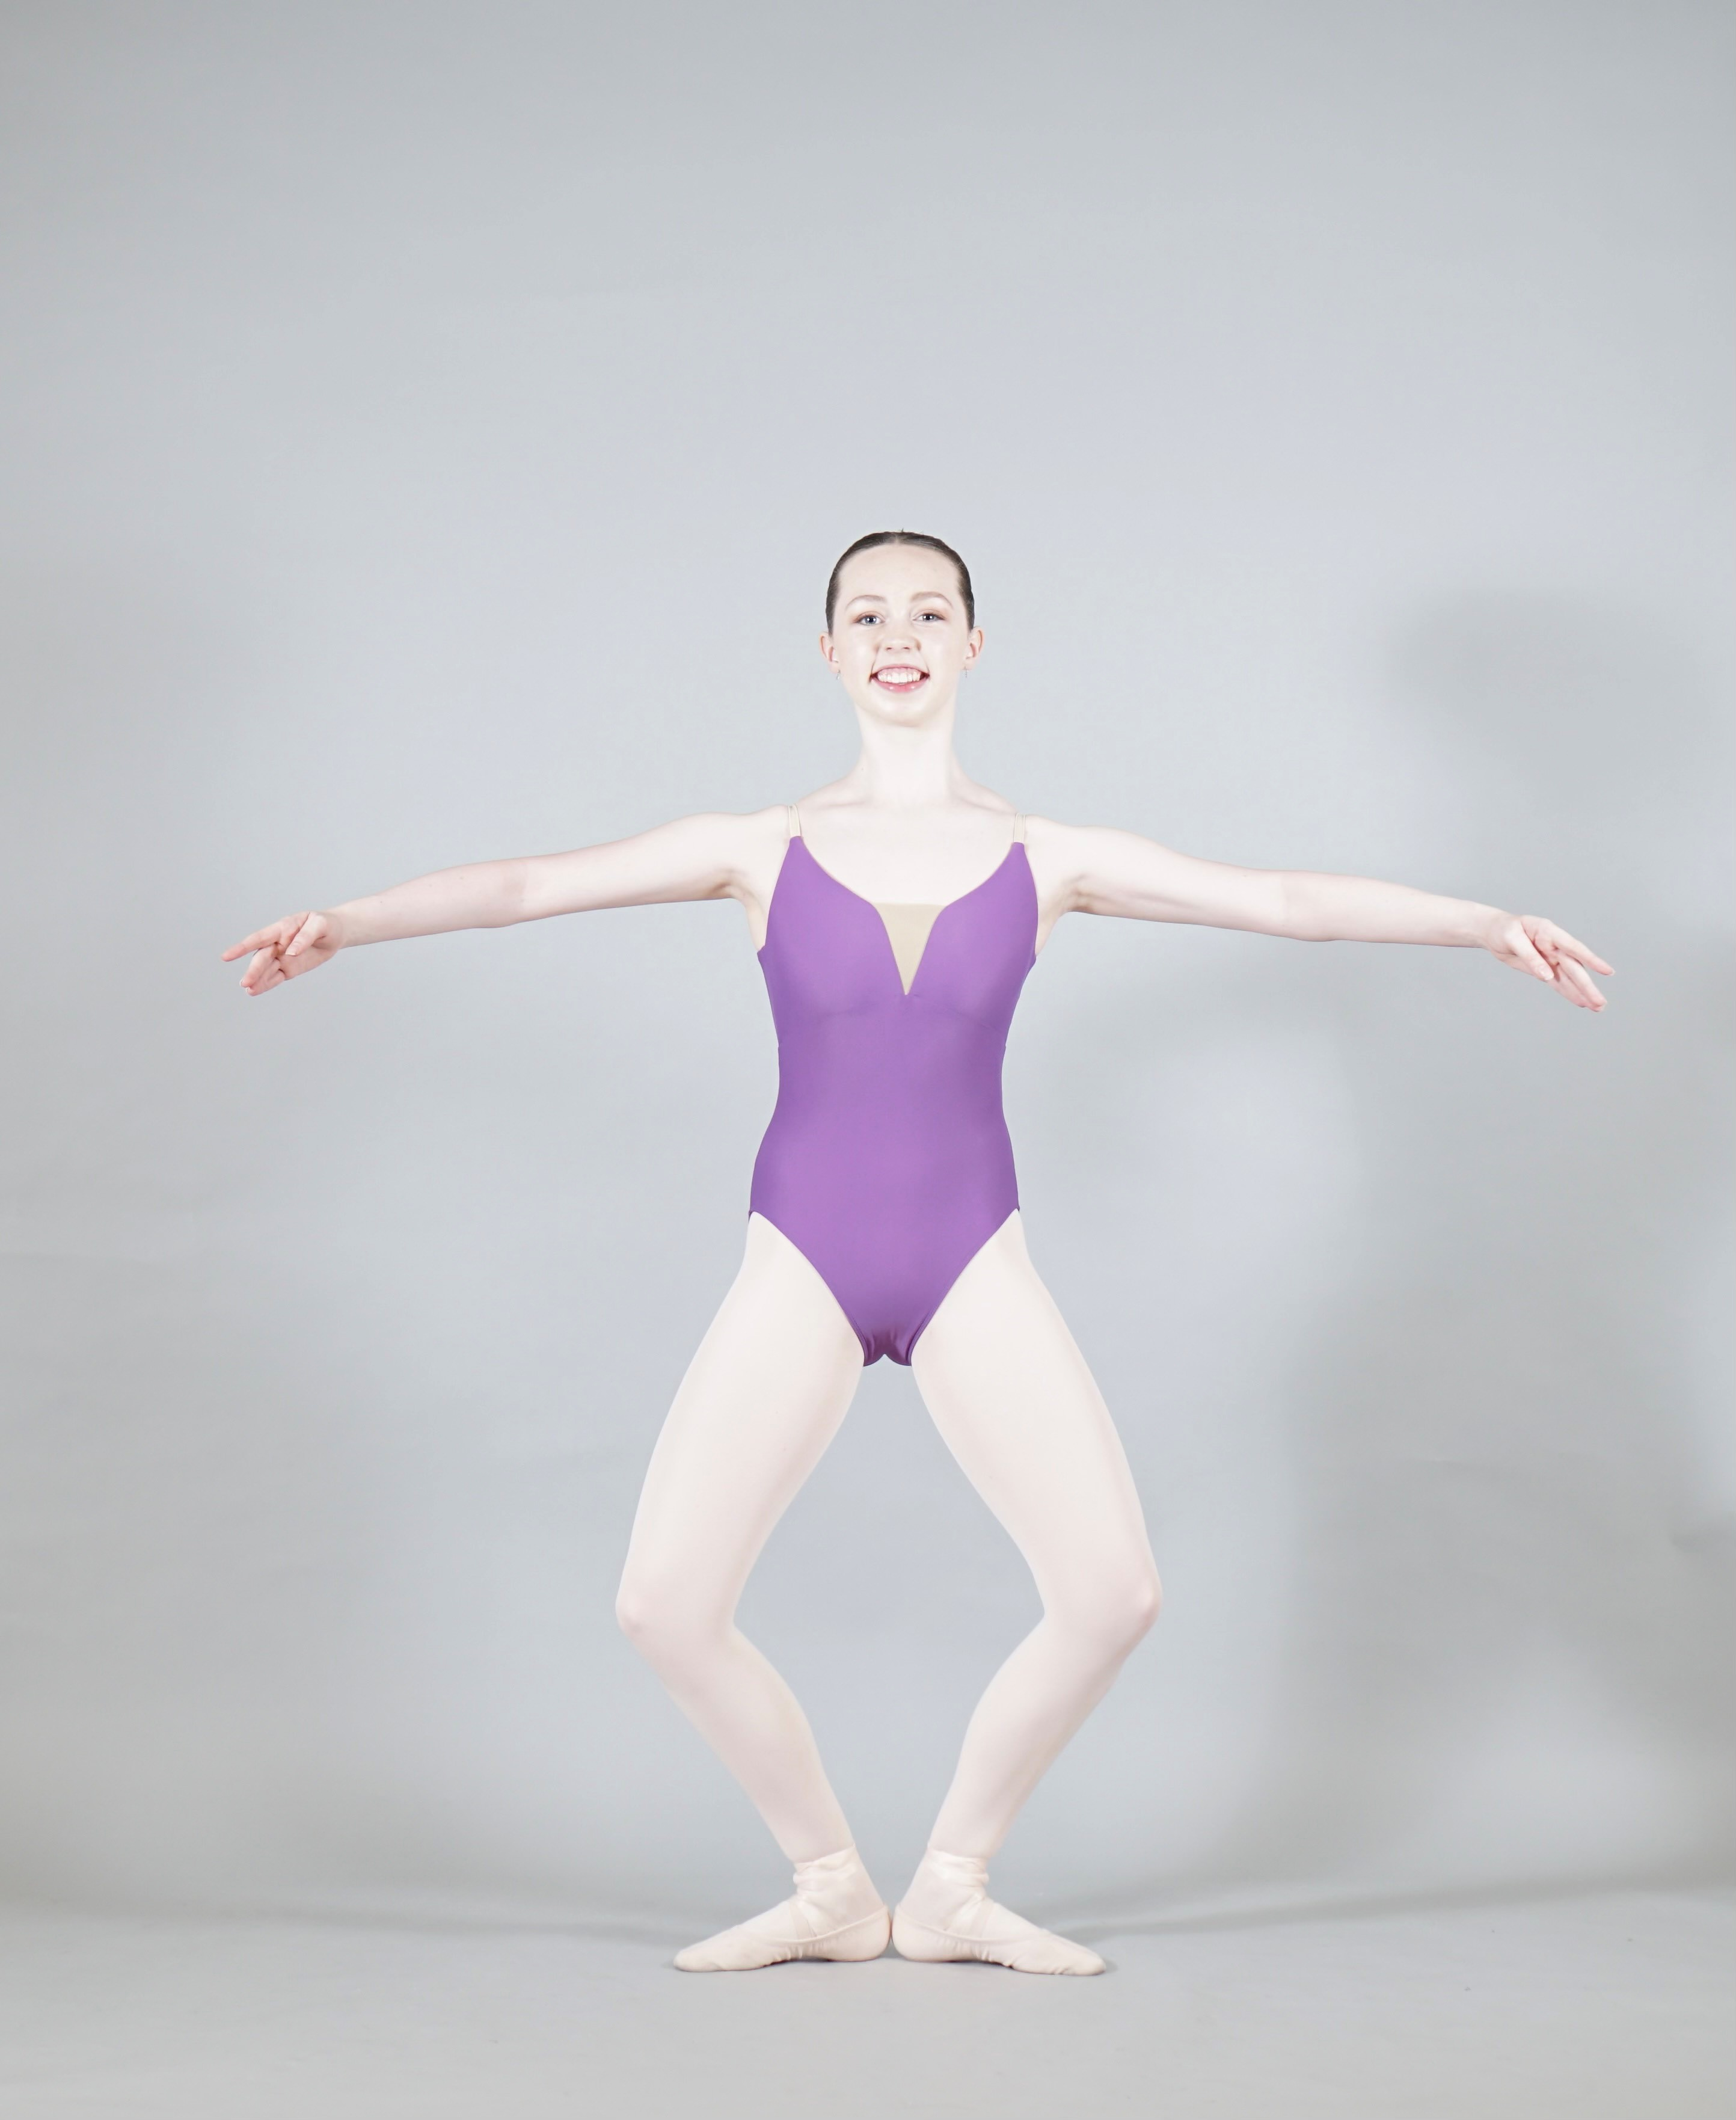
DEMI PLIE

FIRST ARABESQUE